**Additional Guidance linked to our Code of Conduct for all staff, volunteers and visitors to our school.**

Adults should at all times provide a good example and a positive role model to the pupils and to behave in a mature, respectful, safe and fair manner, for example you must ensure that you:

* Are not sarcastic, nor make remarks or jokes of a personal, sexual, racist, discriminatory nature.
* Do not embarrass or humiliate the children.

You must ensure that your relationship with all children remains on a professional footing:

* Treat all children equally – never build special relationships, nor give or receive special gifts.
* Only touch pupils for professional reasons and when it is necessary and appropriate for a pupil’s well-being or safety.
* Do not behave in a way that could lead a reasonable observer to question your conduct.

Ensure that your dress is professional and appropriate for your role.

* Adults should not wear clothing that is viewed as offensive, revealing or sexually provocative.
* Not see through, too short or too low.

**If you have any queries, regarding the information contained in this leaflet, or require further clarification of any points, please do not hesitate to contact the DSL or the Deputy DSL.**

**Great Wishford Church of England**

**VA Primary School**

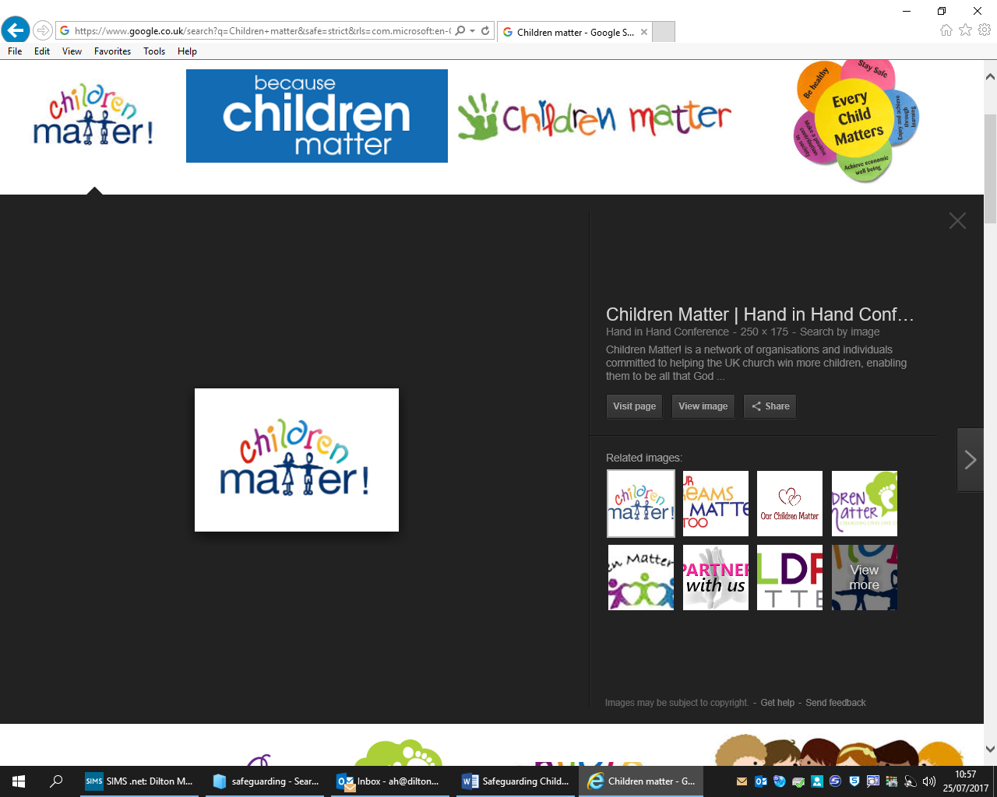

**Safeguarding Children Procedures**

**An information leaflet for visitors and contractors to the school**

**January 2018**

Child Abuse is any form of Physical, emotional or sexual mistreatment or lack of care that leads to harm or injury. It commonly occurs within a relationship and is an abuse of power or a breach of trust. Abuse can happen to any child regardless of age, gender, race or ability.

The school also has a duty to be aware of and respond to any signs of CSE or Child Sexual Exploitation or FGM/Female genital mutilation. Any concerns about either of these should be passed straight to the DSL.

We are also mindful of all the other areas that can cause significant harm to a child, these include radicalisation. Therefore, if you have any concerns about things that you hear or observe whilst in our school please do speak to the DSL/DDSl.

Disclosures of Abuse by a child.

If a pupil ‘discloses’ information about significant harm you should:

* Listen.
* Tell the pupil that you need to pass the information onto someone else.
* Absolute confidentiality is impossible in these circumstances and you should never agree to keep a promise of secrecy.
* Make accurate notes of exactly what was said.

It is important to remember that it is not your responsibility to investigate suspected cases of abuse, only to report them to the DSL.

What Would We Do Next?

We follow the Child Protection Procedures set out by the Wiltshire Safeguarding Children’s Board and available at [www.swcpp.org.uk](http://www.swcpp.org.uk) and take account of guidance issued by the Department for Education in Keeping Children Safe in Education July 2016.

Safeguarding Children Procedures.

Children and young people have a fundamental right to be protected from harm. Families have a right to expect schools to provide a safe and secure environment. All schools have a legal duty to work with other agencies, for example Children’s Social Care and the police, to safeguard children’s welfare.

Aim of this leaflet.

To ensure that all visitors and contractors are aware of their responsibility to promote equal opportunities and to help protect pupils from significant harm.

Guidelines for all visitors.

As a visitor to our school, as either a supply teacher, contractor or working with children in some other capacity, it is important that you are aware of our child protection procedures.

* Our designated safeguarding lead (DSL) is Jill Farndale.
* Our deputy safeguarding Lead (DDSL) is Mandy Hewes.
* The school’s safeguarding Governor is Anna Tattersall.
* If there is any reason to suspect that a pupil has suffered discrimination or is likely to suffer significant harm, you must inform the DSL as above immediately.

What is discrimination?

Discrimination occurs when people receive less favourable treatment on any grounds. This covers race, ethnic or national origin, language, religion or belief, gender and gender reassignment, sexual orientation, disability, social class or where a person lives.

What is Abuse?

There are four main categories of Abuse.

|  |  |  |  |
| --- | --- | --- | --- |
| Physical Abuse | Sexual Abuse | Emotional Abuse | Neglect |