Weekly Home Learning Tasks Year 3:
This week we will be using some additional resources rather than Bitesize and White Rose:

Week  01.06.20 | Monday | Tuesday | Wednesday | Thursday | Friday
Reading | To find more books to read you can log onto OxfordOwl. Please open the Oxford Reading tree document on the class page and follow the step by step guide.  https://home.oxfordowl.co.uk/books/free-ebooks/  You will need to register, but registration is free
 | Daily reading | Daily reading | Daily reading | Daily reading | Daily reading
English | Fix the sentence word mats | Book review. I would like to be able to put some of these up in the library when we come back in September. Can you recommend any books you think would be good for other year groups? You can use the template below or design your own. | David Walliams reading comprehension | Write a letter. This could be to someone you know, someone in another year group or a famous author – many write back! | Free Write: By the Light of the Lanterns  Can you use the questions to help you write a setting description?
Maths | Number and Place Value place Value work book. You can choose which of the worksheets you feel most confident completing. You can complete more than 1 each day, but don’t feel you must complete them all by the end of the week.
Foundation Subject | How many of these activities can you complete this week? You may have already completed some. Have you got photos?  https://www.nationaltrust.org.uk/50-things-to-do  I would love to see what you have been up to and share your pictures on the website. Some activities can also be used to gain Blue Peter Badges:  https://www.bbc.co.uk/cbbc/joinin/about-blue-peter-badges

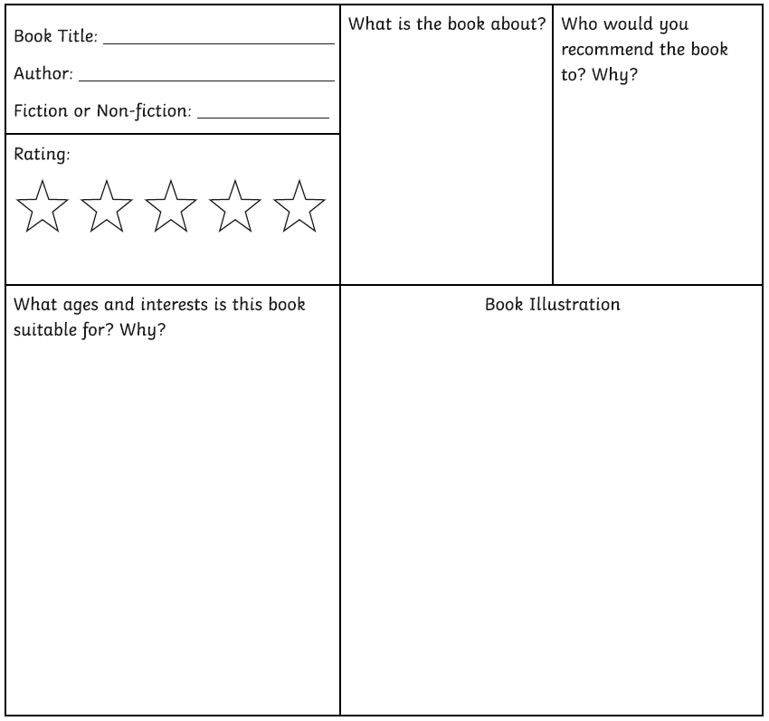

Free Write: By the light of the Lanterns

