You write tWeekly Home Learning Tasks Year 5:
This week we will be using some additional resources rather than Bitesize and White Rose:

Week  01.06.20 | Monday | Tuesday | Wednesday | Thursday | Friday
Reading | To find more books to read you can log onto OxfordOwl. Please open the Oxford Reading tree document on the class page and follow the step by step guide.  https://home.oxfordowl.co.uk/books/free-ebooks/  You will need to register, but registration is free
 | Daily reading | Daily reading | Daily reading | Daily reading | Daily reading
 | Correct the spelling mistakes (below) | Design a new cartoon character. Who are they? What do they do that is funny, strange or cheeky? Can you draw them? Can you create a mini story for them? I would love to see your cartoons… Maybe we can make a book of them to read to other children in school? You can use the template below, or design your own. | Michael Morpurgo reading comprehension | Message in a bottle. If you could write a message to a friend, who would it be? What would you write? Would you put anything else in your bottle? Maybe you could find an empty bottle and complete one? | Free Write – The Artist  Use the picture below to finish the story starter I’ve given you.
Maths | If you have time, I have included a Number and Place Value workbook for you to work through. If there are any areas you aren’t sure of, please email the office, and someone will try to help.
 | Arithmetic paper 1  You don’t have to do these under timed conditions if you don’t want to. If you are a little sticky over some of the methods, go back to my maths for extra practice. | Arithmetic paper 2  You don’t have to do these under timed conditions if you don’t want to. If you are a little sticky over some of the methods, go back to my maths for extra practice. | Arithmetic paper 3  You don’t have to do these under timed conditions if you don’t want to. If you are a little sticky over some of the methods, go back to my maths for extra practice. | Arithmetic paper 4  You don’t have to do these under timed conditions if you don’t want to. If you are a little sticky over some of the methods, go back to my maths for extra practice. | Arithmetic paper 5  You don’t have to do these under timed conditions if you don’t want to. If you are a little sticky over some of the methods, go back to my maths for extra practice.
Foundation Subject | Try one of the activities from the woodland trust below:  https://www.woodlandtrust.org.uk/blog/2020/03/kids-nature-activities-self-isolation/  I would love to see what you have been up to and share your pictures on the website. Some activities can also be used to gain Blue Peter Badges:  https://www.bbc.co.uk/cbbc/joinin/about-blue-peter-badges

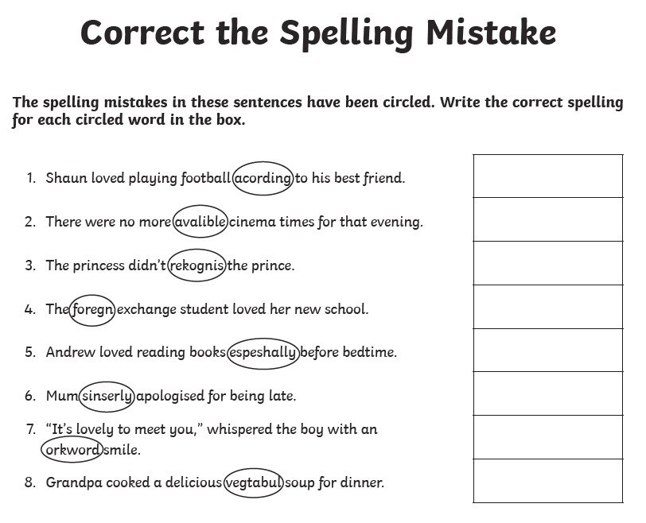
Design a cartoon character

Free write: The Artist
