Free Write

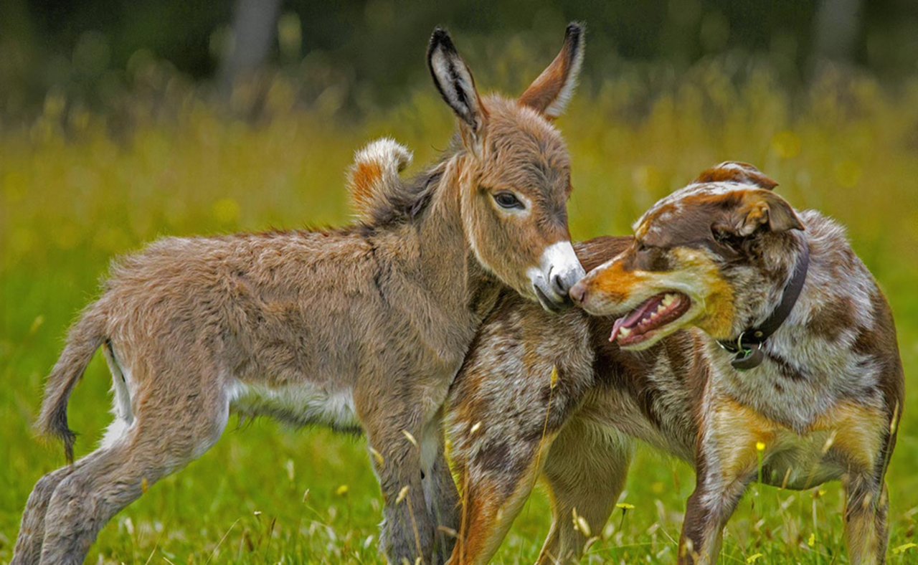

Write about what you can see in the picture and maybe answer the some of the following questions:
What animals can you see in the picture? In what ways are these two animals different? In what ways might they be similar?
How do you think the two animals discovered each other?
How have they become friends? What do you think makes a good friend?
How can you show other people that you are a friendly person?
What kind of people do you like being friends with?

