Free Write

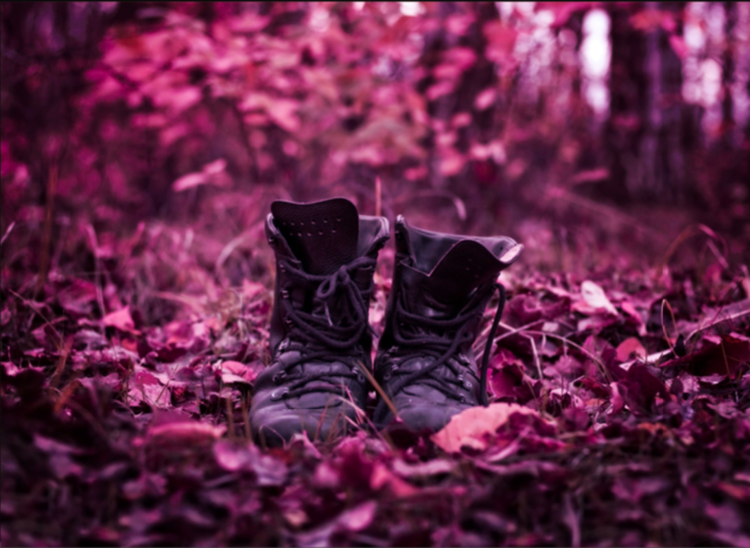
Write about what you can see in the picture and maybe answer the some of the following questions:
Why do the trees have bare branches?
What do you think is happening with the boots?
How did the boots get there in the first place?
What will happen next, now that the boots have started moving?

