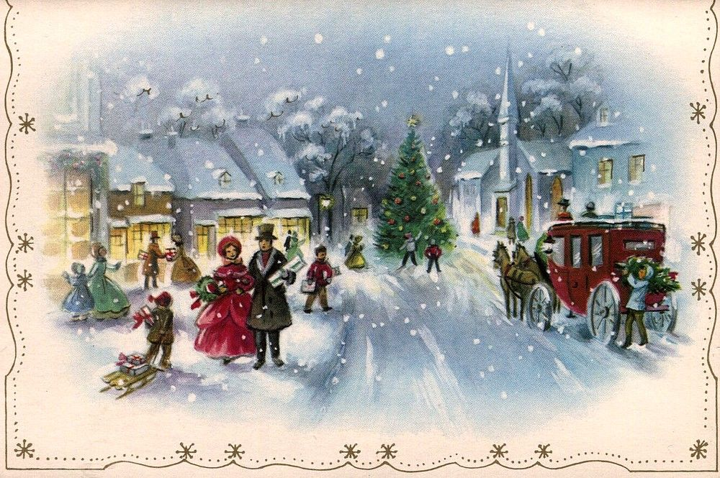

**RE**

This terms R.E focus is based around the key concept of Christianity and God, investigating the question: If God is Trinity, what does that mean for Christians? This will include making links between the concept of the trinity and the roles and actions of God through the ‘big story’ of the bible; giving examples of how the Christian community respond to the idea of God as trinity through symbols, art and in churches and evaluating our learning through expressing our ideas on a given question.

**History**

Our topic this term will be based in the Victorian period. This will include: understanding how the period fits with British history; an understanding of how Queen Victoria has influenced modern Britain; an explanation of the cause and effect of the industrial revolution for rich and poor families; an understanding of the significance Thomas Barnado had on the lives of Victorian children; and using a range of sources to compare the lives of children then and now.

**Maths**

This term we will be extending and consolidating our mathematical knowledge through fluency, reasoning and problem solving in the following areas:

**Year 6:** Fractions – equivalents, simplifying,

calculating with the 4 operations

Position and direction – using all 4 quadrants, reflecting along an axis, translation

**Year 4 & 5:** Multiples and Factors

Prime, square and cube numbers

Multiply and divided by 10, 100, and 1000

Multiplication (mental and formal written method)

Short Division - with remainders (mental and formal written method)

**Times table focus will be on:**

6 x

7 x

9 x

11 x

12 x

Mixed for those who are fluent.

**DT**

This term our main focus will be designing, making and evaluating Victorian confectionary boxes containing traditional sweets, We will be learning to measure, cut and reinforce products for their end use and aesthetic purpose. We would also like to have a special event closer to Christmas focussing on Victorian Christmas crafts… watch this space!

**English**

**Reading:** This term, whilst we will be reading a range of fiction and non-fiction texts to support all areas of the curriculum, our class novel will be ‘A Christmas Carol’ by Charles Dickens. We will be reading an abridged version to immerse the children in the plot, as well as excerpts of the original text to help develop an understanding of the historical setting. We will also be looking at how to answer comprehension questions using Point, Evidence and Explanation.

**Writing:** This term we will be writing an explanation text, linked to our Science topic, and innovating our class novel. We will be learning to use and apply the grammatical knowledge taught last term and this, as well as writing for a purpose and audience. We will also be learning how to plan, draft and edit according to a given success criteria.

**Vocabulary, Grammar and Punctuation:** To tie in with our writing, this term we will be learning to use the following: third person pronouns, a range of conjunctions in compound and complex sentences, commas to separate clauses and the present perfect vs the simple past.

**Science**

This term’s topic is Earth and Space. Our learning will include: describing the relative shapes of the Earth, Moon and Sun and their distances from each other; the movement of the Earth and other planets relative to the Sun, and how this causes night, day and the seasons; the movement of the Moon and how this creates the lunar month. We will be making and using different models, video clips and texts to help develop our understanding, displaying our learning through written explanations.

**Autumn Term 2 2019**

**Peregrine Falcon**