Week  29.6.2020 | Monday | Tuesday |  | Wednesday |  | Thursday |  | Friday
Reading | To find more books to read you can log onto OxfordOwl. Please open the Oxford Reading tree document on the class page and follow the step by step guide.
 | Read to an adult and get them to write in your reading record | Read to an adult and get them to write in your reading record |  | Choose one of your story books and find your favourite page. Why is it your favourite page? Can you draw it and label it, or write a caption/sentence. |  | Read to an adult and get them to write in your reading record. |  | Share a book with an adult. How many of the following tricky words can you find?  the, then, like, said  Count them up and make a tally.
Daily phonic lessons provided by DfE  Phonics phase 4 letter sounds. | Click on the following link for your daily phonics lesson.  - For Reception children who can confidently blend and read words such as ‘fish’ ‘chat’ and ‘rain’ lessons are uploaded at 10am.  - For those who would like extra practise with blending ‘Learning to blend’ is uploaded at 11am.  https://www.youtube.com/channel/UCP_FbjYUP_UtldV2K_-niWw/channels?view_as=public  For Phonics Practice you can access the games on phonics play https://www.phonicsplay.co.uk/
 | Today we are practising “gr”  Say the cluster blends a few times then write the words below  Green  Grandad  Grip  Grub  Remember to use your cursive handwriting. |  | Today we are practising “dr”  Say the cluster blends a few times then write the words below  Drip  Drop  Drink  Dragon  Remember to use your cursive handwriting. |  | Today we are practising “tr”  Say the cluster blends a few times then write the words below  Tree  Trap  Trick  Train  Remember to use your cursive handwriting. |  | Today we are practising “st”  Say the cluster blends a few times then write the words below  Step  Star  Sting  Stack  Remember to use your cursive handwriting. | Today we are practising “fr”  Say the cluster blends a few times then write the words below  Frog  Frown  Fresh  French  Remember to use your cursive handwriting.
Writing | Read the instructions below the plan on how to make a pirate ship. Follow the instructions to construct the pirate ship. |  | Can you recall how you made your pirate ship? What did you do first, next, then and finally? Can you write your own instructions on how to make the pirate ship? Try making another pirate ship following your instructions? Were they correct or did you miss a part out?  Remember to use your cursive handwriting, finger spaces, capital letters and full stops. |  | Read and or listen to the story “The Night Pirates” by P Harris & D Allwright click on the link below to hear the story read https://www.youtube.com/watch?v=rAKdccdXDvo  Can you record any of the characters from the story?  Remember to use your cursive handwriting, finger spaces, capital letters and full stops.  . |  | I would like you to plan your own pirate story using pictures and key words or phrases.  Answering the following questions may help you with your plan. What is your pirate called? What do they look like? Do they have pirate friends? Do they have a pirate ship? Does it have a name? Where are they going in their ship? Do they have a treasure map to follow? Or are they going to add to their treasure trove? Does the island have a name? Do they meet other pirates?  Remember to use your cursive handwriting. | I would like you to use your plan to write your story adding an adjective and more detail, for example instead of writing  Pirate Barnard sailed on the sea.  Try writing  Pirate Barnard sailed on the deep blue, shimmering sea.  Remember to use your cursive handwriting, finger spaces, capital letters and full stops.
Handwriting | Practice the following words.  Grandad has green grubs.  Remember to refer to the letter formation poster |  | Practice the following words.  Dragon drinks drops.  Remember to refer to the letter formation poster |  | Practice the following words.  The tree is by the train track.  Remember to refer to the letter formation poster |  | Practice the following words.  The star is stuck in string.  Remember to refer to the letter formation poster | Practice the following words.  The frog is speaking french.  Remember to refer to the letter formation poster
 | Please refer to White Rose Home Learning Early Years https://whiterosemaths.com/homelearning/early-years/ week commencing 22nd June for a short video lesson followed by activities with further extension activities at the end of the Power point.
Maths | https://wrm-13b48.kxcdn.com/wp-content/uploads/2020/06/Day-1-Zog.pdf |  | https://wrm-13b48.kxcdn.com/wp-content/uploads/2020/06/Day-2-Zog.pdf |  | https://wrm-13b48.kxcdn.com/wp-content/uploads/2020/06/Day-3-Zog.pdf |  | https://wrm-13b48.kxcdn.com/wp-content/uploads/2020/06/Day-4-Zog.pdf | https://wrm-13b48.kxcdn.com/wp-content/uploads/2020/06/Day-5-Zog.pdf
Have some fun, spend some time together. Painting, baking, sitting outside, playing a game…. Or a bit of TV ;)

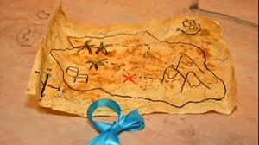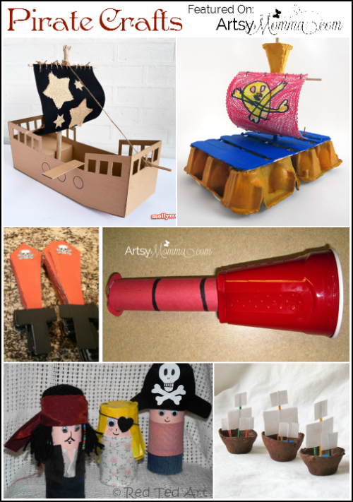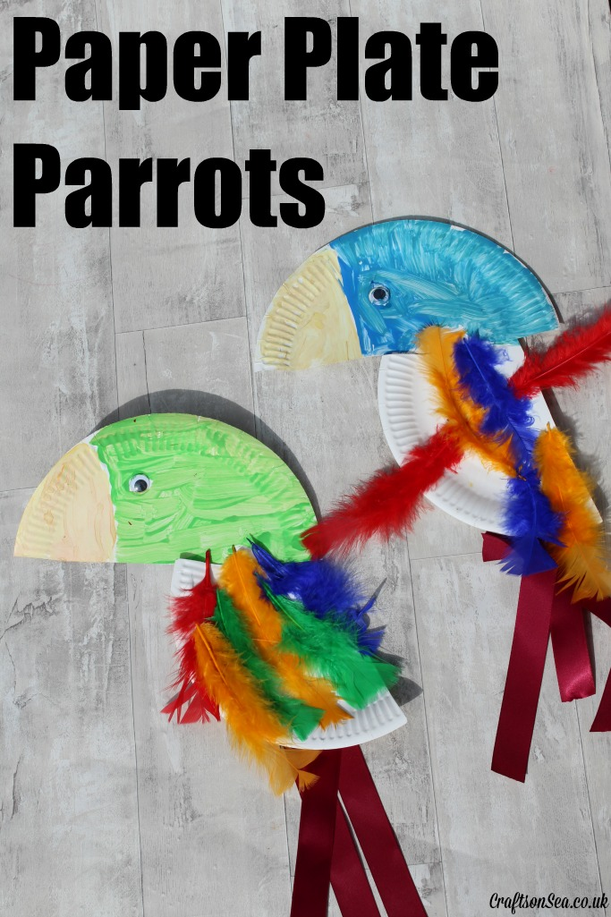

Instructions for making a pirate ship
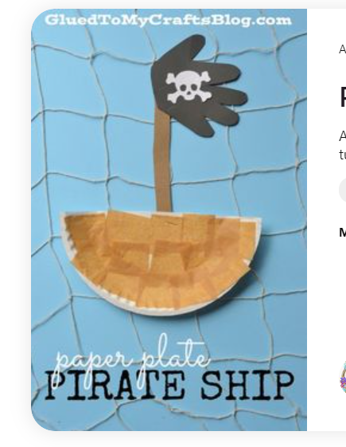
You will need:
- Half a paper plate
- A lolly stick
- A piece of black paper
- Brown paper
- White chalk

- First take your half paper plate.
- Then take your brown paper and cut it into squares.
- Next stick the brown paper to the plate. This will make it look like wood.
- Then take a lolly stick and glue this to the back of the paper plate.
- Next take the black piece of paper and draw round your hand with chalk.
- After that, cut round your hand to make a sail.
- Before you glue your sail to your lolly stick, draw a skull and cross bones with chalk on the hand.
- Finally glue the sail to the lolly stick.

