Year 2 Weekly learning 6th-10th July
This week we are following the timetable from BBC Bitesize.
Please see the link for the daily lessons.
https://www.bbc.co.uk/bitesize/dailylessons
We are now working one week behind so please look on at Monday 29th June’s work as this will be the work for Monday 6th July
Maths is now from White Rose Maths. Please see the link below to access the Maths videos. There are worksheets to accompany the videos. These are available on the class page. Friday will be a challenge from Bitesize, not White Rose.
99 Club will be on the class page. If you are having trouble accessing the class page, please email admin@greatwishford.wilts.sch.uk
Some fun activities for the week:

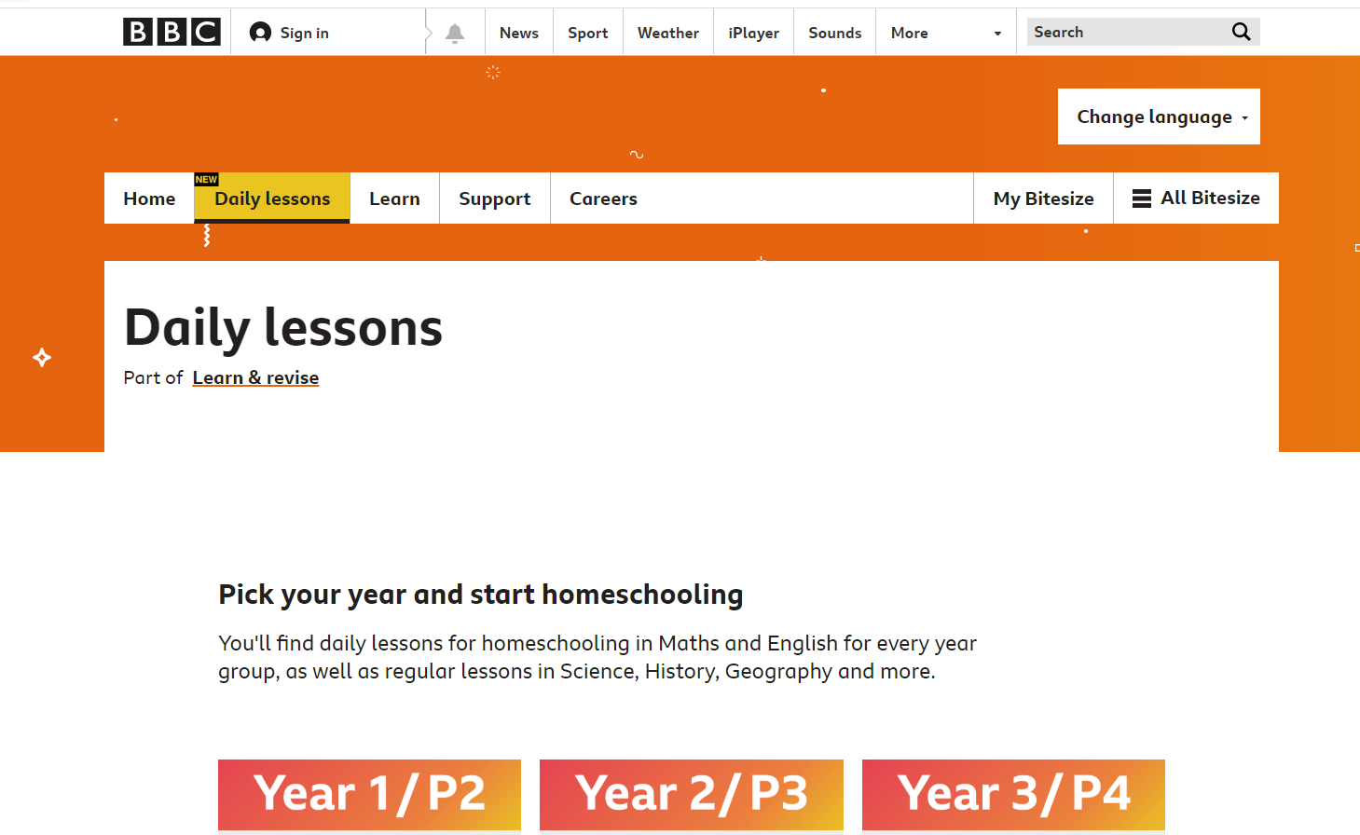

 | Monday | Tuesday | Wednesday | Thursday | Friday
AM | Bitesize English Activity  Yr 2: Questions  Please see 29th June lesson on Bitesize  (Daily phonics letters and sounds.  Spellings and reading) | Bitesize English Activity  Yr 2: Counting Poems  Please see 30th June lesson on Bitesize  (Daily phonics letters and sounds spellings and reading) | Bitesize English Activity  Yr 2: Curly Catepillar letters and apostrophes  Please see 1st July lesson on Bitesize  (Daily phonics letters and sounds spellings and reading) | Bitesize English Activity  Yr 2: Alphabetical order  Please see 2nd July lesson on Bitesize  (Daily phonics letters and sounds spellings and reading) | Bitesize English  Activity  Yr 2: Reading lesson: George’s Marvellous Medicine.  Please see 3rd July lesson on Bitesize  (Daily phonics letters and sounds spellings and reading)
AM | Maths  Yr 2: White Rose Maths  https://vimeo.com/432483400  TT Rockstars and times table practice | Maths  Yr 2: White Rose Maths  https://vimeo.com/432483645  TT Rockstars and times table practice | Maths  Yr 2: White Rose Maths  https://vimeo.com/432483778  TT Rockstars and times table practice | Maths  Yr 2: White Rose Maths  https://vimeo.com/432483882  TT Rockstars and times table practice | Maths  Yr 2: BBC Bitesize Maths Challenge
PM | Bitesize History  Yr 2: Mary Seacole  Walks, baking, painting and any fun activities there is never enough time in the day for. | Bitesize Geography  Yr 2: Introduction to seasons  Walks, baking, painting and any fun activities there is never enough time in the day for. | Bitesize Science  Yr 2: Dinosaurs  Walks, baking, painting and any fun activities there is never enough time in the day for. | Bitesize German  Yr 2: Number Food and drink  Walks, baking, painting and any fun activities there is never enough time in the day for. | Bitesize Design Technology  Yr 2: Sources of energy  Walks, baking, painting and any fun activities there is never enough time in the day for.

