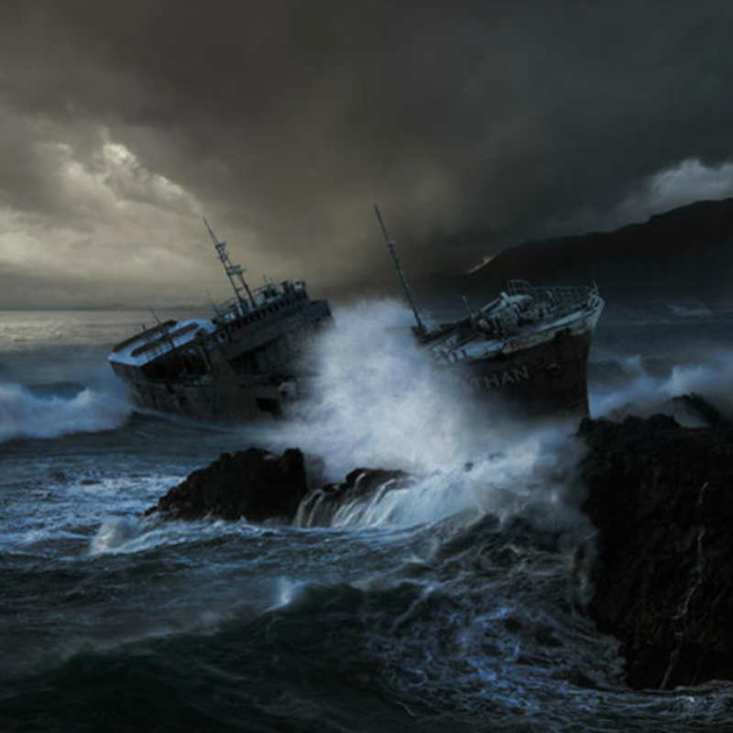
Write about what you can see in the picture and maybe answer some of the following questions:
What do you think the ship’s name is?
Why are storms so dangerous for ships and their crews?
How many crew do you think are on the ship?
Why does a ship need a crew?
How have ships changed over the course of history?
How might the crew escape the ship?

