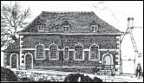

Great Wishford Primary School
Good Behaviour Policy

Rationale

Good behaviour is essential in order to allow Great Wishford Primary School to flourish as a learning community that promotes the well-being of all its members.

Aim

At Great Wishford Primary School, we aim to:

- Provide an environment where children feel safe, secure and respected, enabling children to develop a sense of self-worth and a respect and tolerance for others.
- Ensure all children are ready for learning.
- Focus our attention on the promotion of positive behaviour and on shared responsibility for dealing with instances of unacceptable behaviour
- To promote a shared approach to dealing with discipline issues in school by having clear procedures as set out in this policy.

Agreed procedures:

Rewards

Everything we do at Great Wishford Primary School is centred around our ‘seven expectations:

Determination Aspiration Pride Respect
Resilience Belief Responsibility

We approach the promotion of good behaviour through our six expectations. These expectations are displayed in word form in classes and all around the school. During the year, children discuss these words with their teacher and during assemblies.

We also reinforce and promote positive behaviour through:

- Verbal praise
- Positive body language (a smile, thumbs up etc)
- Stickers.
- Receiving house points.
- Being sent to a Senior Leader to share excellent learning.
- Receiving certificates and awards in assembly.
- VIP lunches with the Head or SLT
- Public recognition e.g. in the school newsletter/website.

.

Consequences

There are six stages of consequences:

Stage 1: Verbal warning
Stage 2: 5 minute loss of lunchtime
Stage 3: 10 minute loss of lunchtime
Stage 4: 15 minute loss of lunchtime
Stage 5: 20 - 30 minutes loss of lunchtime, parents contacted.
Stage 6: 20 – 30 minutes loss of lunchtime, parents contacted and discussion with Head teacher
Internal exclusion may be considered.
Permanent exclusion may be considered.

See Appendix 1 for a fuller explanation of the consequences and Appendix 2 for examples of behaviours that might warrant particular stages.

Consequences can be applied in sequence if a child fails to address their negative behaviour, or, in the case of seriously poor behaviour, stages can be arrived at directly, without having progressed through lesser stages.

Loss of minutes at lunchtime will happen during the lunchtime immediately following the loss of minutes. This will be the same day if minutes are lost in the morning or the following day if minutes are lost in the afternoon. KS2 children missing part of lunchtime will be sent to sit in a classroom under supervision of a member of SLT. KS1 children remain in their own classroom with their own teacher.

If a child is disturbing the learning of others or behaving inappropriately and has not responded to the class teacher’s use of consequences, then the Duty Teacher will be called. This is done either by sending another child to the office with a message.

Children who are removed from their class by the Duty Teacher will be taken to a quiet area to discuss the incident / their behaviour and ways to improve their behaviour choices. They will also be expected to complete all or part of the task that their class were engaged in, whether back in class, in a different class, outside the Head’s office or in another suitable area, which will be decided by the Duty Teacher.

In the case of an Internal Exclusion, children will not go back to their own class, but will complete their work in another classroom under supervision for a pre-defined period of time.

If a child reaches a Stage 5 or 6 then parents will be informed by the class teacher, SLT or Head teacher.

Recording and assessment

When a serious incident occurs, or the Duty Teacher is called, a ‘Duty Teacher/Serious Incident’ form should be completed (See Appendix 3). This will be completed at a convenient time, as close to the event as possible. Completed forms will be handed to the office for filing and kept in a file in the office.

Any allegations of bullying or racism will be recorded on a separate sheet (See Appendix 4). This will be completed by the staff member who dealt with the incident and passed to the office for filing. All forms will be kept in a file in the office.

Blank copies of all forms are kept as hard copies in the filing cabinet in the Staff Room and also electronically on Shared Resources.

To ensure that persistent low-level poor behaviour is drawn to the attention of the school leadership team, a simple weekly record of children’s behaviour in class and which stages they have received is recorded daily, by the class teacher. This together with Incident forms and lists of who is losing minutes of lunchtime on a daily basis are collated and discussed by SLT on a regular basis. (see Appendix 5).

Behaviour at lunchtimes

MDSAs follow the same behaviour policy as other staff. A member of senior staff is on duty at all times and can be called on.

Physical restraint

Physical restraint of children is only to be used as a last resort in situations where it is necessary to prevent injury to any person or serious damage to property. All other means of de-escalating the situation should have been exhausted, including making clear what the consequences of the child’s actions will be, before resorting to physical restraint which should only be undertaken by “Team Teach” trained members of staff.

Appendix 1: Behaviour Management Chart

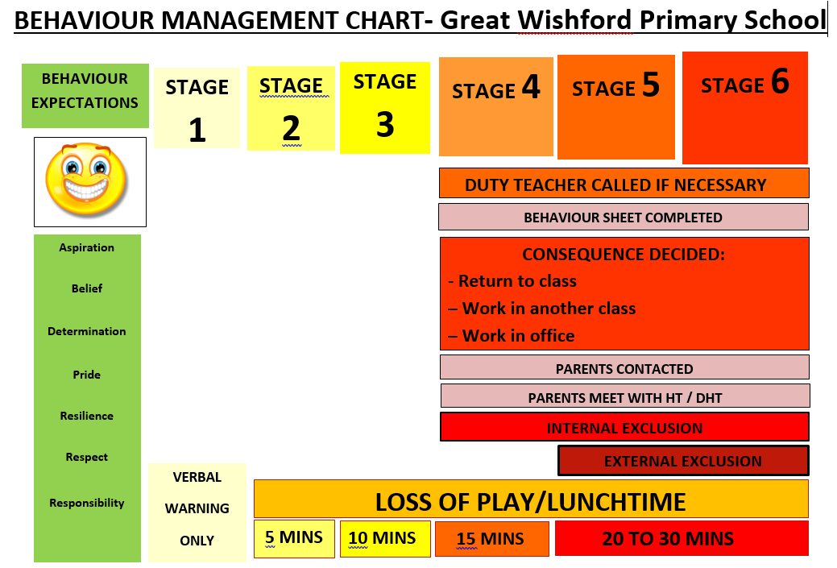

Appendix 2: Behaviour Management Chart – Consequences

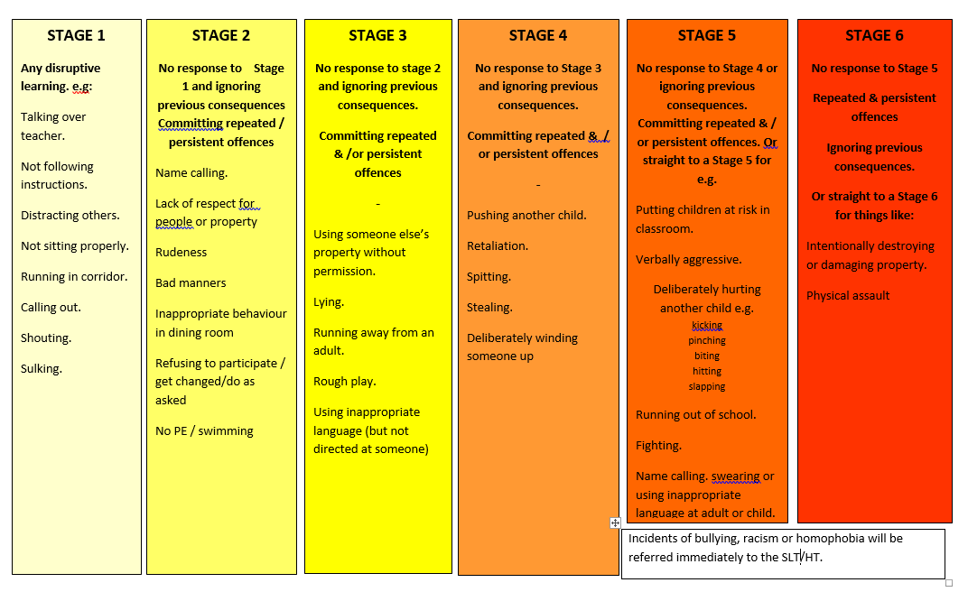

Appendix 3:
Great Wishford Primary School
Behaviour Incident Form Serious Incident/Duty Teacher called called
Child’s name: | Date: | Time:
Class teacher: | Year group & class:
PLEASE WRITE YOUR NAME AND DATE IN EACH SECTION YOU COMPLETE
What led up to the incident? What was the context/location (if relevant):

 | Name of person recording & date
Details of incident:

 | Name of person recording & date
Child’s comments/account:

What action did the Duty Teacher /or person dealing with incident take? Please state outcome?

OUTCOME: Stage 4 / 5 / 6 / 7 / Internal Exclusion / External Exclusion Othe Other:
Parents contacted: Yes / no TA aw Teacher aware: Yes / no Head Head / SLT aware? Yes / no | Name of person who decided outcome :  Comp Completed form to MH for filing: yes / no

Appendix 4:
BEHAVIOUR INCIDENT FORM (Racial / Bullying)
Child’s name: | Date: |  | Time: | Stage if approp:
Class teacher: | Year group and class:
PLEASE WRITE YOUR NAME AND DATE IN EACH SECTION YOU COMPLETE
What led up to the incident? What was the context? Wher Where did incident occur? - classroom/toilet/hall/dining hall/library/playground/field/other (circle)
 |  | Name of person recording & date
Details of incident: Witnesses – please record names of adults/children: Any w

Child’s comments / account: (use reverse if more than one child involved).
 |  | Child’s name:
What happened after the incident? What action was taken? Who was duty teacher?
 |  | Name of person recording & date
Class Teacher Informed: yes/no  Or TA Informed: yes/no  Head or SLT aware if appropriate: yes/no |  | Parents contacted: by who?/when?  Completed form to MH for filing. Yes/no

Appendix 5: CLASS LIST OF STAGES

BEHAVIOUR MANAGEMENT CHART w/c………………………………… 2017/18

Name | Mon | Tues | Weds | Thurs | Fri | Total weekly house points
Name

Please remember – for those incidents that are a Stage 4 and above – please use appropriate form to record what the behaviour was that led to the incident/Stage being given.

Updated: September 2017
This Policy will be reviewed annually.
Review date: September 2018

