Welcome to the Lockdown Library!

We want to make sure pupils are still reading for pleasure during lockdown – as we know how much regular reading habits can positively impact on children’s attainment in school.

Why is reading for pleasure important in lockdown?
• Research shows that reading for fun improves children’s literacy – reading for enjoyment will support the literacy teaching your child is receiving remotely.
• For relaxation and to ‘switch off’ - audiobooks can be a good break for the eyes as well!
• For escapism – even young children are aware that this is a strange and worrying time. Books can provide a welcome escape into another world.

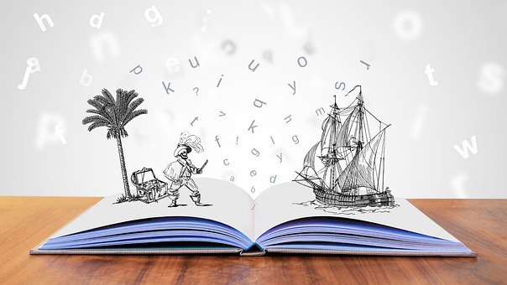
Image: https://pixabay.com/illustrations/storytelling-fantasy-imagination-4203628/

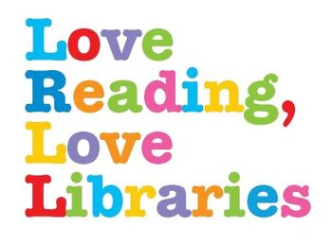
Access to Wiltshire Library eBooks
- To join as a member: https://libraries.wiltshire.gov.uk/web/arena/join-the-library
- Then register here to access books online, for free: https://wiltshire.rbdigitalglobal.com/

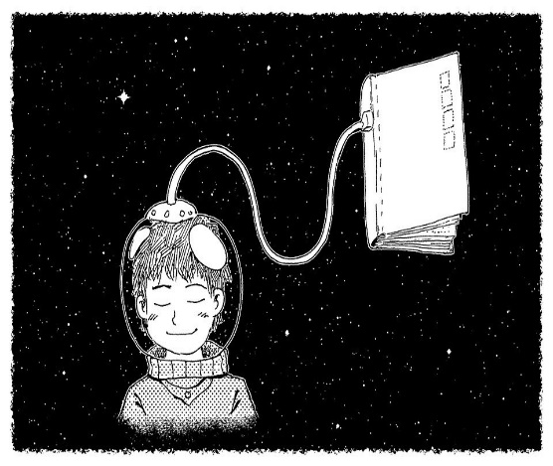
Reading resources: Younger readers: EYFS and KS1
https://pixabay.com/illustrations/fairy-tale-fantasy-dream-night-1077863/

- Oxford Reading Owl website: lots of eBooks Free eBook library | Oxford Owl from Oxford University Press
- Free book online ‘Staying Home’ – perfect for explaining lockdown to small people: https://www.andersenpress.co.uk/wp-content/uploads/2020/04/STAYING_HOME_medium-res.pdf
- Fairy tales: an audiobook and text printed. Useful for reading along: Small Stories Archives - Storynory
- Top ten story-times to enjoy: Links to authors reading their stories: https://researchrichpedagogies.org/_downloads/Top-Ten-Storytimes-to-Enjoy.pdf
- Links to poster and QR codes to scan- takes you to the author reading their stories: https://www.booksfortopics.com/storytime-online-3-5
https://www.booksfortopics.com/storytime-online-5-7
- Some famous faces reading picture books : https://www.storylineonline.net/ (copy link into browser)
- Books Alive! Is a great YouTube story playlist- some firm favourites on here, like The Day Crayons Quit, and Supertato
- Reading Challenges – ideas to get children excited about reading: For 3-5 year olds,
For 5-7 year olds

Reading resources: KS2
- Oak Academy are releasing a book a week to access on in their Virtual School Library | Oak Academy (thenational.academy)
- A range of free on line children’s e-books including non -fiction
- www.researchify.co.uk/audiobooks.html - includes 6 free children's classics as PDF and word docs, with accompanying audio books: Alice in Wonderland, Wind in the Willows, The Railway Children, The Jungle Book, Peter Pan Black Beauty
- Audible books for children- free
- Download posters and scan the QR codes to hear authors reading their stories:
- https://www.booksfortopics.com/storytime-online-7-9 https://www.booksfortopics.com/storytime-online-9-11
- Reading challenges to get children enthusiastic about reading: For 7-9 year olds,
For 9-11 year olds
https://pixabay.com/photos/book-landscape-nature-wind-weather-2929646/
Author pages
- A huge variety of authors reading along on this YouTube playlist
- Harry Potter fans: Wizarding World: The Official Home of Harry Potter
- Cressida Cowell is reading How to Train your Dragon - a chapter a day! The early chapters are on YouTube.
- Michael Rosen’s YouTube channel- stories and poems for children - old favourites https://m.youtube.com/user/artificedesign
- David Walliams reads his stories here

What to read next?
- Looking for book recommendations for children who have been hooked in by a particular series or author and are ready to branch out? From Harry Potter and Tom Gates to Rainbow Magic and The Worst Witch – these posters suggest what to read next https://www.booksfortopics.com/branching-out

Websites to explore new books
- www.toppsta.com - a website full of book recommendations, including videos and activity packs. There are over 55,000 books reviews - all by children! It also has daily collations of various events happening on line: https://toppsta.com/blog/view/bookish-ideas-if-you're-self-isolating-with-the-kids
- Great extracts and master class videos on the World Book Day site!
- Love My Books - another free website providing resources, activity ideas and book suggestions for children aged 0-9. Pages of great ideas for parents and children sharing books together

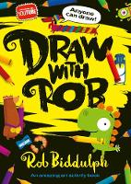
Get creative – activity ideas linked to reading
- Lovely website with lots of activities linked to books: Creative Archive - authorfy
- Book related creative activities, including How to Draw a Gruffalo https://www.bl.uk/childrens-books
- Nick Sharratt’s Drawing Tips - Lots of videos with drawing activities based on his well-known books such as the Daisy series by Kes Gray, plus the characters for Jacqueline Wilson’s books and more.
- Draw along with Jim Field - author of Oi Frog! https://www.jimfield.me/draw
- Rob Biddulph Draw Along Videos during lockdown 1, Rob posted an online video twice a week for pupils to draw along with him – all stored on this page
- Nosy Crow Activity Sheets- lots of free to download ideas, games, creative activities and puzzles linked to some of Nosy Crow’s best loved books including picture books and fiction for the 8 -12 age group.

How can I support my child’s reading?
- Keep a reading routine in place where you listen to your child read, or read to them.
- Take advantage of all the amazing free reading resources online during the lockdown!
- Encourage children to switch off devices half an hour before they go to bed, and read instead. It’s a habit, and they only need 10-20 minutes a night regularly. Start with shorter times if needed. Taking away the blue light will also ensure that your child gets better quality sleep.
- Use rewards to help motivate your child to read if they are reluctant, and praise and encourage them as they read.
- Let them listen to audio books as an alternative.
- Don’t discourage them from reading non-fiction, comics or magazines – everything helps.
- Let them reread old favourites as well as age-appropriate reads.
- Let them use the internet to engage in being enthusiastic about books: https://www.beano.com/categories/books is a good place to start!
- Ask them about their reading—especially if they are reading independently now. Get them to read their favourite bit to you. Ask them questions about what they think will happen next. Borrow their books and read them and then discuss them.
- Read with TRUST: a useful poster to suggest how to talk to your child about their reading: https://educationendowmentfoundation.org.uk/public/files/Publications/Covid-19_Resources/Resources_for_schools/Reading_with_TRUST_comic.pdf
- Talk to your child about your reading habits, or books you enjoyed at their age.
- Help them with reading home learning by checking they understand the words, directing them to a dictionary to check unfamiliar words, getting them to read it to you or summarise it for you.
- Get them to make a reading den—somewhere cosy and small where they can enjoy reading. Lots of ideas here.
- https://literacytrust.org.uk/family-zone/ - Is full of ideas to help you support children from babies up to 11 year old children with literacy at home - includes downloadable resources, video clips, recommended websites and apps.
- https://researchrichpedagogies.org/research/supporting-rah more helpful tips for parents
- A useful blog if your child struggles to read

