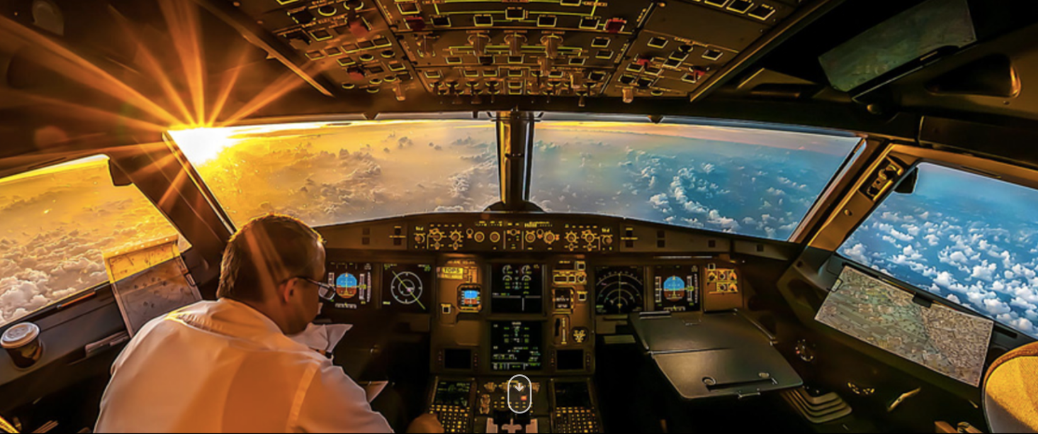
Free Write

Write about what you can see in the picture and maybe answer the some of the following questions:
Where is the plane flying?
How did the pilot know how to fly a plane?
Was it a smooth plane journey?
What will happen next, now that the plane has landed?

