T6 Summer 2 |  | Owl R/ Y1  Ongoing revisit to consolidate EYFS skills- Labels, lists, captions, real and imaginary rhyming words | Hedgehog Y2/ Y3 | Fox Y4/ 5/ 6
Class reader for pleasure  Guided reading text |  | The Boy who lived with Dragons by Andy Shepherd  Custard the Dragon by Ogden Nash | Flat Stanley in Space by Jeff Brown  Picture a Poem by Gina Douthwaite | The House with Chicken Legs by Sophie Anderson  Y4 Cloudbusting by Malorie Blackman  The Wonder Garden by Jenny Broom  Y6 & 5 Wonder by R.J. Palacio
Books to model/ support writing  Additional reading resources | Purpose
 | 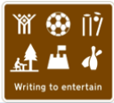 | * nursery rhymes  Twinkle Twinkle chocolate bar by John Foster  *fantasy stories (dragons) - description  Custard the Dragon by Ogden Nash  How to speak Dragonese by Cressida Cowell | *shape (concrete) poem  Picture a Poem by Gina Douthwaite  Bob Raczka Wet Cement A Mix of Concrete Poems  *fantasy story – Space - description  Flat Stanley in Space by Jeff Brown  Charlie and the Glass Elevator by Roald Dahl | *riddle poetry  What am I by Pie Corbett  *Fantasy Stories – creating atmosphere  The Eye of The Storm Literacy shed  Never Ending Story by Michael Ende  The Golden Compass by Phillip Pullman
 | 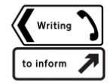 | *Letter  The Lighthouse Keepers Lunch by Ronda and David Armitage | *Poster  Authentic road safety posters
 | 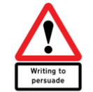
 | 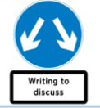 |  |  | *balanced argument  Write Stuff by Jane Considine

