Suggested Weekly Home Learning Tasks:
Week  15.6. 2020 |  | Monday | Tuesday | Wednesday | Thursday | Friday
Reading |  | To find more books to read you can log onto OxfordOwl. Please open the Oxford Reading tree document on the class page and follow the step by step guide.
 |  | Read to an adult and get them to write in your reading record | Read to an adult and get them to write in your reading record | Choose one of your story books and find your favourite page. Why is it your favourite page? Can you draw it and label it, or write a caption/sentence. | Read to an adult and get them to write in your reading record. | Share a book with an adult. How many of the following tricky words can you find?  could, their, called. people  Count them up and make a tally.
Phonics |  | The Department for Education have put together daily phonic lessons, Letters and Sounds for home and school which you can watch on YouTube. Please click on the ‘letter to parents’ and follow guidance. There is a link on the letter that will take you to the YouTube page.  For additional Phonics Practice please use https://www.phonicsplay.co.uk/
 |  | Please use https://www.bbc.co.uk/bitesize/dailylessons for the following week beginning 8th June English and Foundation subject lessons or your red button on your TV
English |  |  | 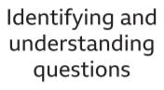 | . | 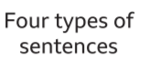 | 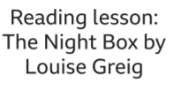
 |  | Maths is now on White Rose https://whiterosemaths.com/ please use the link with each lesson heading. There are worksheets to accompany the videos.
Maths |  | https://vimeo.com/425797171 | . https://vimeo.com/425797292 | https://vimeo.com/425797444 | https://vimeo.com/425797578 | .  Please refer to BBC Bitesize for today’s work
Foundation Subject |  |  |  | 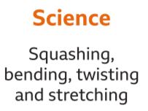 | 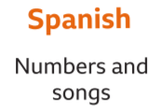

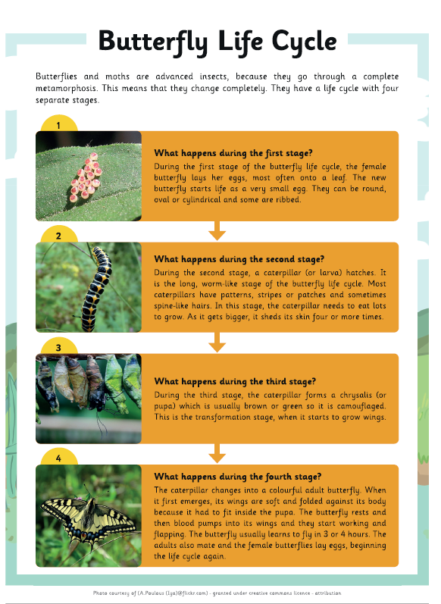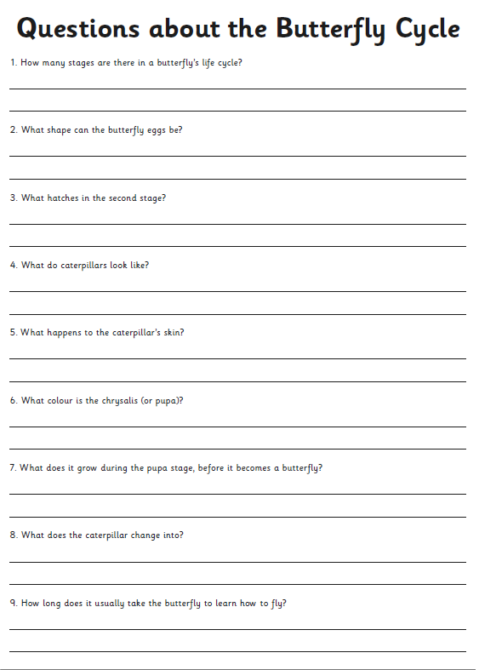
Free Write

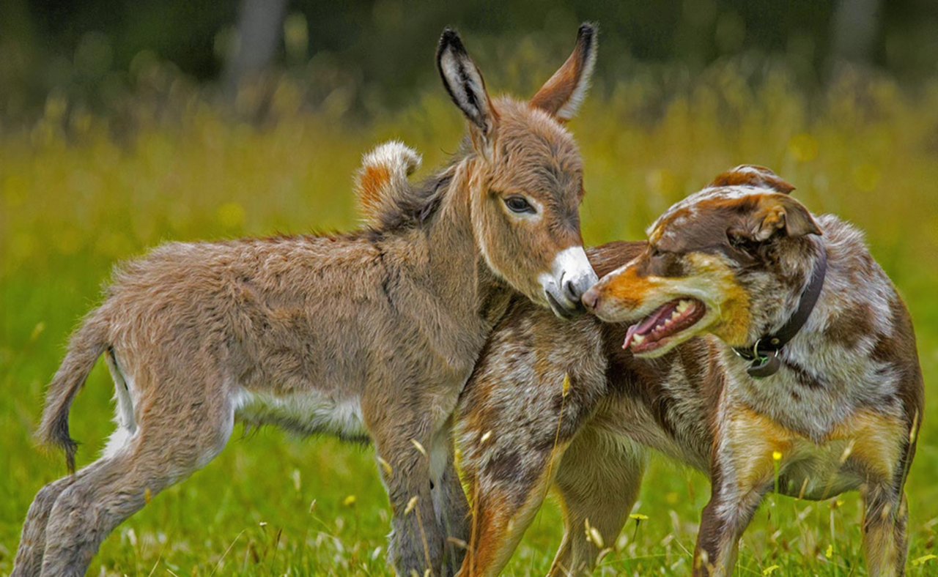

Write about what you can see in the picture and maybe answer the some of the following questions:
What animals can you see in the picture? In what ways are these two animals different? In what ways might they be similar?
How do you think the two animals discovered each other?
How have they become friends? What do you think makes a good friend?
How can you show other people that you are a friendly person?
What kind of people do you like being friends with?

