Year 2 Weekly learning 29th June – 3rd July
This week we are following the timetable from BBC Bitesize.
Please see the link for the daily lessons.
https://www.bbc.co.uk/bitesize/dailylessons
We are now working one week behind so please look on at Monday 22nd June’s work as this will be the work for Monday 29th June.
Maths is now from White Rose Maths. Please see the link below to access the Maths videos. There are worksheets to accompany the videos. These are available on the class page. Friday will be a challenge from Bitesize, not White Rose.
99 Club will be on the class page. If you are having trouble accessing the class page, please email admin@greatwishford.wilts.sch.uk
Some fun activities for the week:

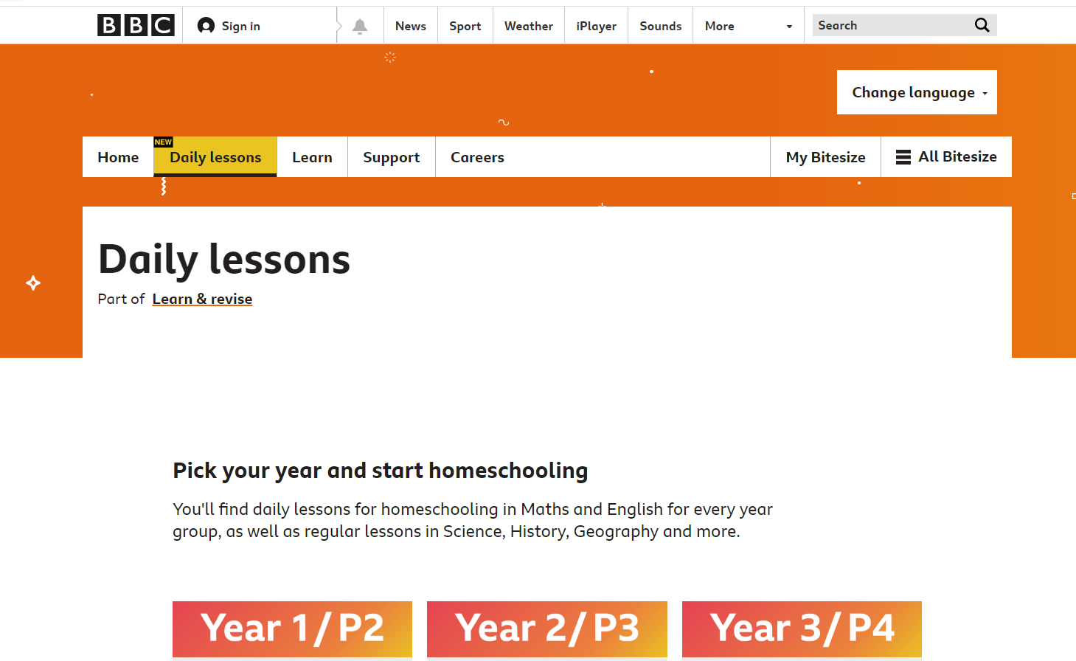

 | Monday | Tuesday | Wednesday | Thursday | Friday
AM | Bitesize English Activity  Yr 2: Verbs  Please see 22nd June lesson on Bitesize  (Daily phonics letters and sounds.  Spellings and reading) | Bitesize English Activity  Yr 2: First, Second Third Person  Please see 23rd June lesson on Bitesize  (Daily phonics letters and sounds spellings and reading) | Bitesize English Activity  Yr 2: National Writing Day lesson  Please see 24th June lesson on Bitesize  (Daily phonics letters and sounds spellings and reading) | Bitesize English Activity  Yr 2: Using one armed robot letters in description  Please see 25th June lesson on Bitesize  (Daily phonics letters and sounds spellings and reading) | Bitesize English  Activity  Yr 2: Reading lesson Ella Bella Ballerina and a Midsummer Night’s Dream by James Mayhew.  Please see 26th June lesson on Bitesize  (Daily phonics letters and sounds spellings and reading)
AM | Maths  Yr 2: White Rose Maths https://vimeo.com/430299105  TT Rockstars and times table practice | Maths  Yr 2: White Rose Maths  https://vimeo.com/430299221  TT Rockstars and times table practice | Maths  Yr 2: White Rose Maths  https://vimeo.com/430299420  TT Rockstars and times table practice | Maths  Yr 2: White Rose Maths  https://vimeo.com/430109855  TT Rockstars and times table practice | Maths  Yr 2: Maths Challenge
PM | Bitesize History  Yr 2: Florence Nightingale  Walks, baking, painting and any fun activities there is never enough time in the day for. | Bitesize Geography  Yr 2: Cities, towns and villages.  Walks, baking, painting and any fun activities there is never enough time in the day for. | Bitesize Science  Yr 2: What is sound?  Walks, baking, painting and any fun activities there is never enough time in the day for. | Bitesize Design Technology  Yr 2: Food and nutrition  Walks, baking, painting and any fun activities there is never enough time in the day for. | Bitesize French  Yr 2: Food and Drink  Walks, baking, painting and any fun activities there is never enough time in the day for.

