Weekly Home Learning Tasks Year 4:
This week we will be using some additional resources rather than Bitesize and White Rose:

Week  01.06.20 | Monday | Tuesday | Wednesday | Thursday | Friday
Reading | To find more books to read you can log onto OxfordOwl. Please open the Oxford Reading tree document on the class page and follow the step by step guide.  https://home.oxfordowl.co.uk/books/free-ebooks/  You will need to register, but registration is free
 | Daily reading | Daily reading | Daily reading | Daily reading | Daily reading
English | Correct the spelling mistakes 1 | Book review. I would like to be able to put some of these up in the library when we come back in September. Can you recommend any books you think would be good for other year groups? You can use the template below or design your own. | Captain Tom Moore reading comprehension | Write a letter. This could be to someone you know, someone in another year group or a famous author – many write back! How about writing to Captain Tom Moore? | Free Write – The Artist  Use the picture below to finish the story starter I’ve given you.
Maths | If you have time, I have included a Number and Place Value workbook for you to work through. If there are any areas you aren’t sure of, please email the office, and someone will try to help.
 | Arithmetic paper 1  You don’t have to do these under timed conditions if you don’t want to. If you are a little sticky over some of the methods, go back to my maths for extra practice. | Arithmetic paper 2  You don’t have to do these under timed conditions if you don’t want to. If you are a little sticky over some of the methods, go back to my maths for extra practice. | Arithmetic paper 3  You don’t have to do these under timed conditions if you don’t want to. If you are a little sticky over some of the methods, go back to my maths for extra practice. | Arithmetic paper 4  You don’t have to do these under timed conditions if you don’t want to. If you are a little sticky over some of the methods, go back to my maths for extra practice. | Arithmetic paper 5  You don’t have to do these under timed conditions if you don’t want to. If you are a little sticky over some of the methods, go back to my maths for extra practice.
Foundation Subject | Try one of the activities from the woodland trust below:  https://www.woodlandtrust.org.uk/blog/2020/03/kids-nature-activities-self-isolation/  I would love to see what you have been up to and share your pictures on the website. Some activities can also be used to gain Blue Peter Badges:  https://www.bbc.co.uk/cbbc/joinin/about-blue-peter-badges

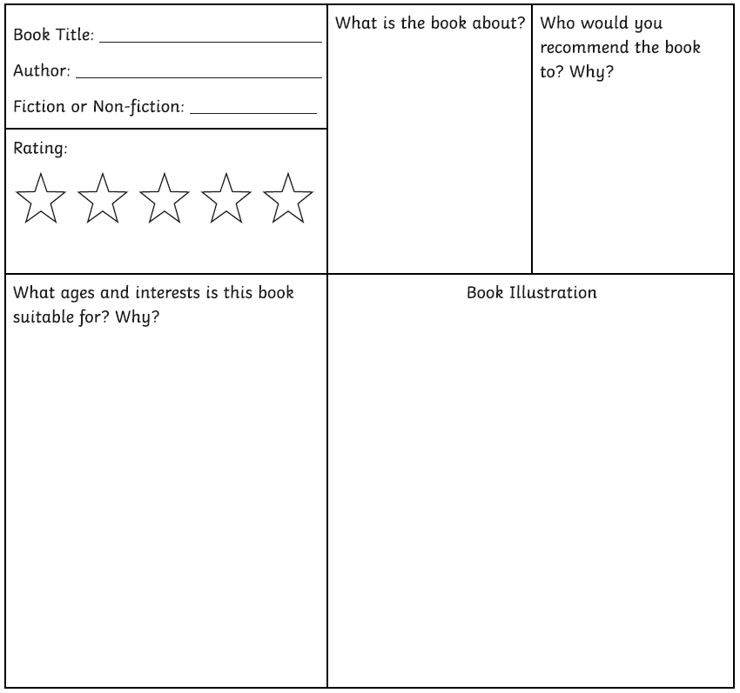
Without Gravity Free write The Artist
