Suggested Weekly Home Learning Tasks:
Week  6.7. 2020 |  | Monday | Tuesday | Wednesday | Thursday | Friday
Reading |  | To find more books to read you can log onto OxfordOwl. Please open the Oxford Reading tree document on the class page and follow the step by step guide.
 |  | Read to an adult and get them to write in your reading record | Read to an adult and get them to write in your reading record | Choose one of your story books and find your favourite page. Why is it your favourite page? Can you draw it and label it, or write a caption/sentence. | Read to an adult and get them to write in your reading record. | Share a book with an adult. How many of the following tricky words can you find?  So, do, one, out, little  Count them up and make a tally.
Phonics |  | The Department for Education have put together daily phonic lessons, Letters and Sounds for home and school which you can watch on YouTube. Please click on the ‘letter to parents’ and follow guidance. There is a link on the letter that will take you to the YouTube page.  For additional Phonics Practice please use https://www.phonicsplay.co.uk/
 |  | Please use https://www.bbc.co.uk/bitesize/dailylessons for the following week beginning 29th June English and Foundation subject lessons or your red button on your TV
English |  | Questions | Counting Poems | .  Curly caterpillar letters and exclamation marks | Alphabetical Order | Reading Lesson:  George’s Marvellous Medicine by Roald Dahl
 |  | Maths is now on White Rose https://whiterosemaths.com/ please use the link with each lesson heading. There are worksheets to accompany the videos.
Maths |  | Counting to 100  https://vimeo.com/432401517 | Recognising Coins  https://vimeo.com/432401693 | Recognising Notes  https://vimeo.com/432401840 | Counting Money  https://vimeo.com/432401953 | .  Please refer to BBC Bitesize for today’s work – Challenge of the week
Foundation Subject | History  Stephen Hawking |  | Geography  Introduction to the Seasons | Science  Dinosaurs | German  Numbers, Food and drink | Design and Technology  Sources of Energy

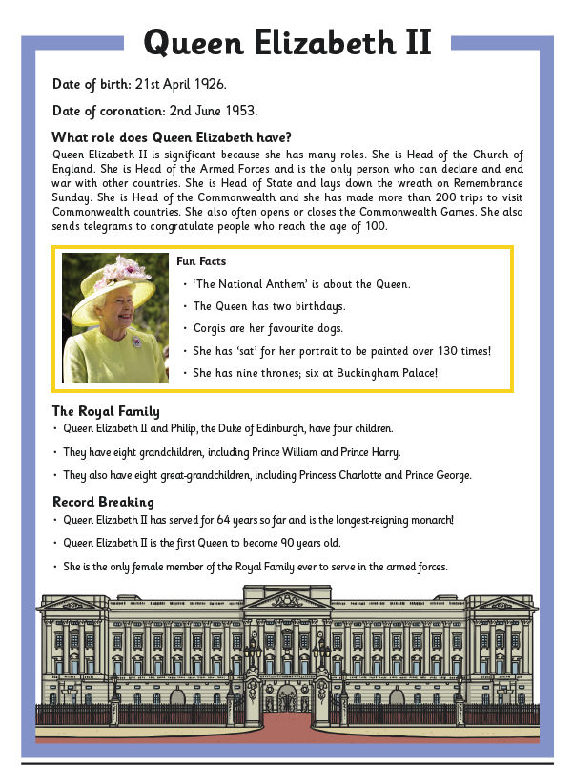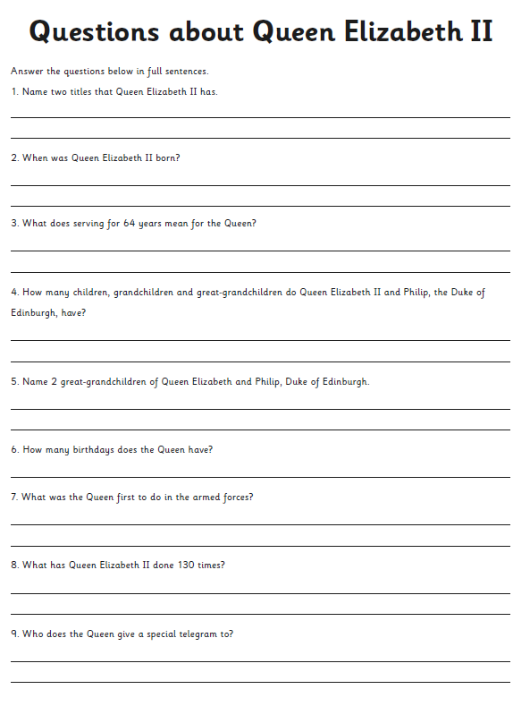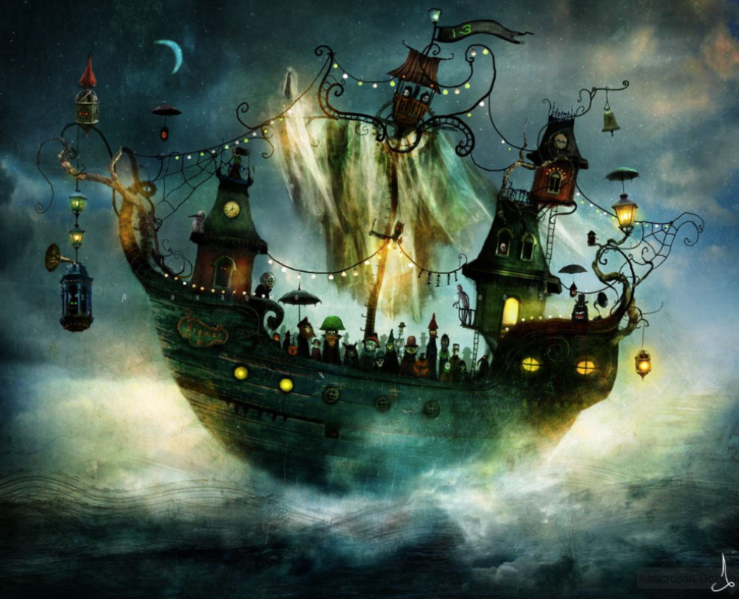
Write about what you can see in the picture and maybe answer the some of the following questions:
What is it that is so strange about the ship?
Who do you think the crew are?
How old do you think the ship is?
What do you think the number 13 on the flag means?
What do you think the bell is used for?
Is there anything else strange that you notice about the picture?

