Week  15.6.2020 | Monday | Tuesday |  | Wednesday |  | Thursday |  | Friday
Reading | I expect you have finished your school reading books by now. To find more books to read you can log onto OxfordOwl. Please open the Oxford Reading tree document on the class page and follow the step by step guide.
 | Read to an adult and get them to write in your reading record | Read to an adult and get them to write in your reading record |  | Choose one of your story books and find your favourite page. Why is it your favourite page? Can you draw it and label it, or write a caption/sentence. |  | Read to an adult and get them to write in your reading record. |  | Share a book with an adult. How many of the following tricky words can you find?  he, we, be, she, me  Count them up and make a tally.
Daily phonic lessons provided by DfE  Phonics phase 4 letter sounds. | Click on the following link for your daily phonics lesson.  - For Reception children who can confidently blend and read words such as ‘fish’ ‘chat’ and ‘rain’ lessons are uploaded at 10am.  - For those who would like extra practise with blending ‘Learning to blend’ is uploaded at 11am.  https://www.youtube.com/channel/UCP_FbjYUP_UtldV2K_-niWw/channels?view_as=public  For Phonics Practice you can access the games on phonics play https://www.phonicsplay.co.uk/
 | Today we are practising “nk”  Say the cluster blends a few times then write the words below  Pink  Sink  Think  Wink |  | Today we are practising “ft”  Say the cluster blends a few times then write the words below  Gift  Swift  Lift  Shift |  | Today we are practising “sk”  Say the cluster blends a few times then write the words below  Skull  Skin  Skip  Skill |  | Today we are practising “lt”  Say the cluster blends a few times then write the words below  Belt  Melt  Felt  Shelter | Today we are practising “lp”  Say the cluster blends a few times then write the words below  Help  Kelp  Gulp  Yelp
Writing | Read and or listen to the story “The Very Hungry Caterpillar” by Eric Carle click on the link below to hear the story read by the author himself  https://www.youtube.com/watch?v=vkYmvxP0AJI |  | Write the days of the week in order then write them in rainbow colours. |  | Recall and write a list of any of the food the Hungry Caterpillar ate. |  | Recall and write food was eaten on what day? | Complete the sentence, If I were a hungry caterpillar I would eat……….  Can you challenge yourself to use alliteration for example a sizzling salami, purple plums, an amazing apple
Handwriting | Practice the following sentence.  I think the sink is pink.  Remember to refer to the letter formation poster |  | Practice the following sentence.  I left the gift in the lift!  Remember to refer to the letter formation poster |  | Practice the following sentence.  The skull’s skill is to skip.  Remember to refer to the letter formation poster |  | Practice the following sentence.  The felt belt was going to melt.  Remember to refer to the letter formation poster | Practice the following sentence.  I need help to gulp.  Remember to refer to the letter formation poster
Maths | 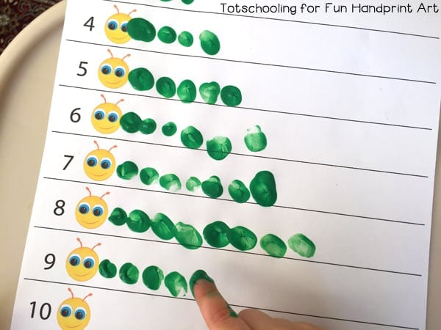  Write the numerals 1 -20 down the left hand side of the page. Make a number caterpillar for each numeral using finger paints or colouring pens/pencils. |  | Open the document titled Yr R maths Tuesday and either print or copy to complete the Number sequencing caterpillars. |  | Open the document titled Yr R maths Wednesday and either print or copy to complete the caterpillars colour patterns. |  | . Open the document titled Yr R maths Thursday and either print or copy to complete the caterpillar addition.  See if you can challenge yourself to complete each of the sheets. | Draw a selection of caterpillars and cut them out. Place them in order of size from shortest and longest.
Have some fun, spend some time together. Painting, baking, sitting outside, playing a game…. Or a bit of TV ;)
