Free Write Week commencing 06/07/20
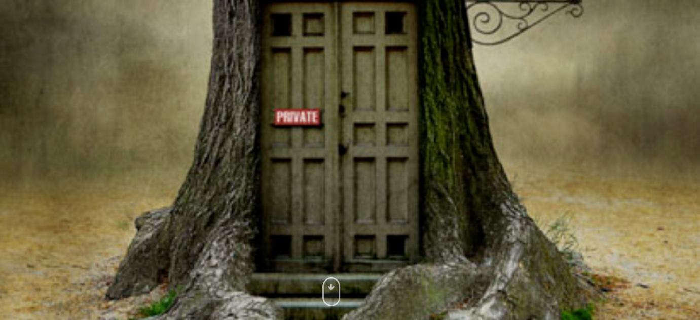
- What happens when you open the door of the tree?
- Where will you go?
- What will you see?
- Who will be behind the door?

