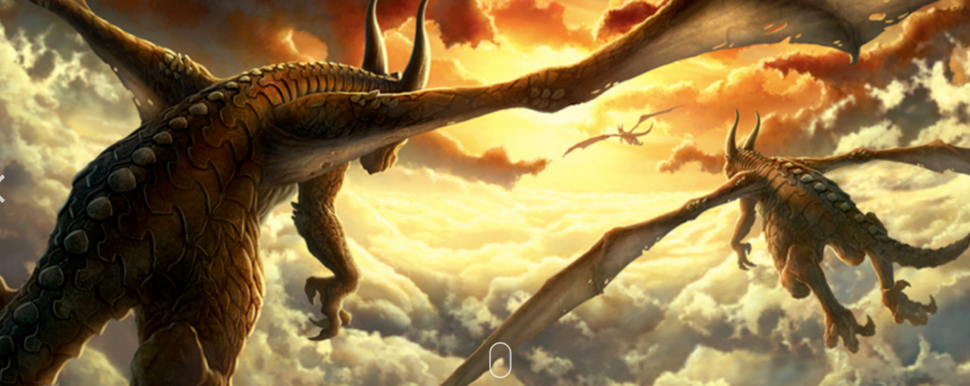
Free Write

What do these creatures look like?
Where are they going?
What will see on the way?
What will happen when they get there?

