Year 2 Weekly learning 8th June- 12th June
This week we are following the timetable from BBC Bitesize.
Please see the link for the daily lessons.
https://www.bbc.co.uk/bitesize/dailylessons
We are now working one week behind so please look on at Monday 1st June’s work as this will be the work for Monday 8th June.
Maths is now from White Rose Maths. Please see the link below to access the Maths videos. There are worksheets to accompany the videos. These are available on the class page. Friday will be a challenge from Bitesize, not White Rose.
99 Club will be on the class page. If you are having trouble accessing the class page, please email admin@greatwishford.wilts.sch.uk
Some fun activities for the week:

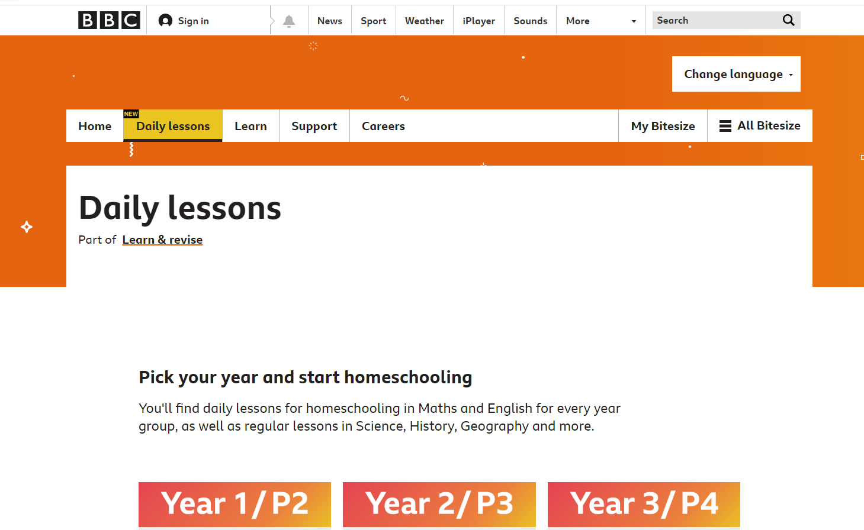

 | Monday | Tuesday | Wednesday | Thursday | Friday
AM | Bitesize English Activity  Yr 2: Using capital letters and punctuation  Please see 1st June lesson on Bitesize  (Daily phonics letters and sounds.  Spellings and reading) | Bitesize English Activity  Yr 2: Write command sentences using a range of punctuation.  Please see 2nd June lesson on Bitesize  (Daily phonics letters and sounds spellings and reading) | Bitesize English Activity  Yr 2: What are suffixes  Please see 3rd June lesson on Bitesize  (Daily phonics letters and sounds spellings and reading) | Bitesize English Activity  Yr 2: Using noun phrases and exclamation marks in writing.  Please see 4th June lesson on Bitesize  (Daily phonics letters and sounds spellings and reading) | Bitesize English  Activity  Yr 2: Forming letters correctly and using the suffixes –ly  Please see 5th June lesson on Bitesize  (Daily phonics letters and sounds spellings and reading)
AM | Maths  Yr 2: White Rose Maths  The 10 times tables  https://vimeo.com/420582220  TT Rockstars and times table practice | Maths  Yr 2: White Rose Maths  Sharing  TT Rockstars and times table practice  https://vimeo.com/420582354 | Maths  Yr 2: White Rose Maths Grouping  https://vimeo.com/420582476  TT Rockstars and times table practice | Maths  Yr 2: White Rose Maths  Odd and even numbers  https://vimeo.com/420582476  TT Rockstars and times table practice | Maths  Yr 2: Maths Challenge
PM | Bitesize History  Yr 2: Gandhi  Walks, baking, painting and any fun activities there is never enough time in the day for. | Bitesize Geography  Yr 2: Introduction to South America Rio de Janeiro  Walks, baking, painting and any fun activities there is never enough time in the day for. | Bitesize Science  Yr 2: Habitats  Walks, baking, painting and any fun activities there is never enough time in the day for. | Bitesize French  Yr 2: Counting and food and drink  Walks, baking, painting and any fun activities there is never enough time in the day for. | Bitesize Design Technology  Yr 2: Packaging  Walks, baking, painting and any fun activities there is never enough time in the day for.

