Year 2 Weekly learning 22nd-27th June
This week we are following the timetable from BBC Bitesize.
Please see the link for the daily lessons.
https://www.bbc.co.uk/bitesize/dailylessons
We are now working one week behind so please look on at Monday 15th June’s work as this will be the work for Monday 22nd June.
Maths is now from White Rose Maths. Please see the link below to access the Maths videos. There are worksheets to accompany the videos. These are available on the class page. Friday will be a challenge from Bitesize, not White Rose.
99 Club will be on the class page. If you are having trouble accessing the class page, please email admin@greatwishford.wilts.sch.uk
Some fun activities for the week:

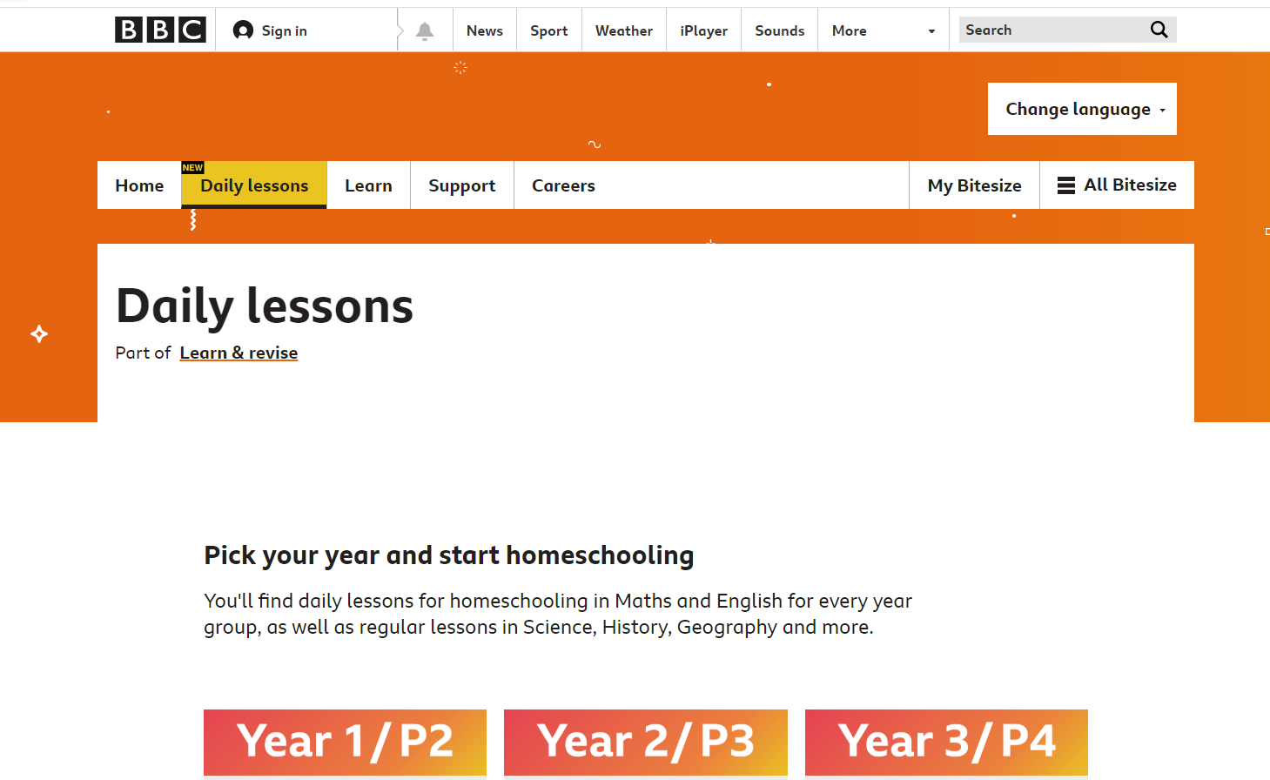

 | Monday | Tuesday | Wednesday | Thursday | Friday
AM | Bitesize English Activity  Yr 2: Identifying errors in writing.  Please see 15th June lesson on Bitesize  (Daily phonics letters and sounds.  Spellings and reading) | Bitesize English Activity  Yr 2: Using the days of the weeks in sentences.  Please see 16th June lesson on Bitesize  (Daily phonics letters and sounds spellings and reading) | Bitesize English Activity  Yr 2: Using long ladder letters in writing  Please see 17th June lesson on Bitesize  (Daily phonics letters and sounds spellings and reading) | Bitesize English Activity  Yr 2: Creating adverts and using describing words.  Please see 18th June lesson on Bitesize  (Daily phonics letters and sounds spellings and reading) | Bitesize English  Activity  Yr 2: Reading lesson: Spike the Hedgehog who lost his prickles by Jeanne Willis.  Please see 19th June lesson on Bitesize  (Daily phonics letters and sounds spellings and reading)
AM | Maths  Yr 2: White Rose Maths  https://vimeo.com/428007654  TT Rockstars and times table practice | Maths  Yr 2: White Rose Maths  https://vimeo.com/428007789  TT Rockstars and times table practice | Maths  Yr 2: White Rose Maths  https://vimeo.com/428007909  TT Rockstars and times table practice | Maths  Yr 2: White Rose Maths  https://vimeo.com/428007983  TT Rockstars and times table practice | Maths  Yr 2: Maths Challenge
PM | Bitesize History  Yr 2: William Shakespeare  Walks, baking, painting and any fun activities there is never enough time in the day for. | Bitesize Geography  Yr 2: Introduction to Antarctica  Walks, baking, painting and any fun activities there is never enough time in the day for. | Bitesize Science  Yr 2:  Parts of the body and senses  Walks, baking, painting and any fun activities there is never enough time in the day for. | Bitesize Design Technology  Yr 2: Repeat Pattern Making  Walks, baking, painting and any fun activities there is never enough time in the day for. | Bitesize Design Technology  Yr 2: Using the web safely  Walks, baking, painting and any fun activities there is never enough time in the day for.

