-----

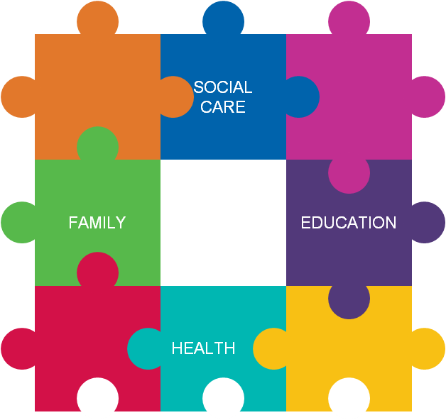

Insert the one page profile here

First Name | Surname | Preferred Name

Home Address | Date of Birth | Gender
 | Home Language | Ethnic Origin
My family and people who are important to me

Parent(s) or carer(s):

Names | Addresses (if different)
Parental responsibility?
Phone number | Email

Other people who are important to me

Name | Who they are and why they are important

Everyone’s views on what’s working well or not working

What’s Working | What’s Not Working
Parent views

Setting views

Other professional views

All about me

My health, physical development and mobility
.

How I communicate (and how to communicate with me)

How I feel, behave and get on with others

My learning, understanding, working out things & solving problems

My family, my home and where I live

Taking care of and doing things for myself, keeping safe

Activities and having fun

Future Plans

Main Identified Needs

What outcomes do I want? | What are my needs? | What will help me get there?

Advice and Information used

Document/Information | Written by | Dated

Next Review Date

Dated ……………………………..

Signed by all those who took part in this My Support Plan

Child / Young person | Parents / Carers | Teacher/Tutor | SENCO
Specialist | Teaching assistant | Other | Other

My Support Plan Review 1 Date 9th March 2018

Attendees |  |  |  |  | Role
New advice or involvement of outside agencies |  |  |  |  | Date
Views on what’s working / not working
Child / young person
Parent/carer
School or setting
Outside Agency
Additional or revised outcomes? |  | Any new or clarified needs? |  | Any changes to help?
Actions and next review date
NEXT MEETING:

My Support Plan Review 2 Date

Consent to share this information with other agencies (if required)
We need consent to be able to work with other professionals to offer the best help possible. Please read this page and sign below if you are happy for us to share the information in this My Support Plan with other professionals in order to coordinate support.

Data Protection
Wiltshire Council is a data controller under the Data Protection Act 1998 and will comply with the requirements of the Act at all times. We will ensure that your information is treated in confidence and used only for the purpose of supporting you or your child through the My Support Plan process.
Consent statement
I have read the contents of this My Support Plan and understand information may be shared between different professionals working with my family in connection with this early help process. Such professionals may include, amongst others, teachers, nurses, therapists, psychologists, youth workers, social workers, education support services, integrated youth services, community health services, early years services, voluntary sector, police, army welfare, bordering local authorities and lead professionals in other counties as appropriate (you can note any exceptions below).

Giving your consent
I have read and understood the consent statement above.
I am aware of and understand the reasons for this My Support Plan.
I/we have given consent to this My Support Plan and also give consent for it to be registered & shared (including with lead professionals in other local authority areas as appropriate).
Parent/Carer:  Signature:  Date  Child or young person:  Signature:  Date: | Parent/Carer:  Signature:  Date

Exceptions:
Please state any services or agencies you do not wish to share information with and give supporting reasons. | Child or young person:  Parent/Carer:

For the professional completing and registering this form:
I confirm the original copy of this My Support Plan has been given to the child young person and/or
I confirm the original copy of My Support Plan has been given to the parent(s)/carer(s).
Name: | Signature: | Date:

Early years settings’ information about attainment and progress (this must be included if requesting a EHC needs assessment)
Current attainments from standardised tests
(assessed within 3 months of making a request and should cover basics skills and any other relevant areas)
Name of test and administrator | Date and chronological age | Age equivalent | Standard Score | Percentile

Information on progress in the curriculum and towards other outcomes
Early Years Foundation Stage aspect | Attainment at previous review  (please describe the learning outcome)  Date: | Current Assessment  (please describe the learning outcome)  Date: | Predicted level or age expectations | If current attainment is below age expectations please give detailed comments.  Please include barriers to learning, e.g. attendance issues, self-esteem/confidence issues etc. and note the support given.

School information about attainment and progress (this must be included if requesting a EHC needs assessment)
Current attainments from standardised tests
(assessed within 3 months of making a request and should cover basics skills and any other relevant areas)
Name of test and administrator | Date and chronological age | Age equivalent | Standard Score | Percentile

Results from previous standardised attainment tests
Name of test and administrator | Date and chronological age | Age equivalent | Standard Score | Percentile

Information about progress in the curriculum and towards other relevant outcomes
 | Current assessment against end of keystage expectations  or other progress measure (date) | Assessment against end of keystage expectations  or other progress measure at last review (date) | Previous assessment against end of keystage expectations  or other progress measure (date)
English
Maths
Science
Other

College information about attainment and progress towards achieving course outcomes (this must be included if requesting a EHC needs assessment)
Current attainments from standardised tests
(assessed within 3 months of making a request and should cover basics skills and any other relevant areas)
Name of test and administrator | Date and chronological age | Age equivalent | Standard Score | Percentile

Information about progress in the curriculum and towards other relevant outcomes
 | Current NC level or other progress measure (date) | NC level or other progress measure at last review (date) | Previous NC level or other progress measure (date)
English
Maths
Science
Other

