Weekly Home Learning Tasks:
Week  8.6.2020 |  | Monday | Tuesday |  | Wednesday | Thursday |  | Friday
Reading |  | To find more books to read you can log onto OxfordOwl. Please open the Oxford Reading tree document on the class page and follow the step by step guide.
 |  | Read to an adult and get them to write in your reading record | Read to an adult and get them to write in your reading record |  | Choose one of your story books and find your favourite page. Why is it your favourite page? Can you draw it and label it, or write a caption/sentence. | Read to an adult and get them to write in your reading record. |  | Share a book with an adult. How many of the following tricky words can you find?  people, called, looked, asked  Count them up and make a tally.
Phonics |  | The Department for Education have put together daily phonic lessons, Letters and Sounds for home and school which you can watch on YouTube. Please click on the ‘letter to parents’ and follow guidance. There is a link on the letter that will take you to the YouTube page.  For additional Phonics Practice please use https://www.phonicsplay.co.uk/
 |  | Please use https://www.bbc.co.uk/bitesize/dailylessons for the following week beginning 1st June English and Foundation subject lessons or your red button on your TV
English |  | 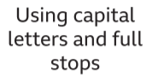 |  |  |  |  | 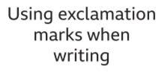 |  | 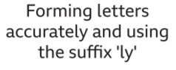
 |  | Maths is now on White Rose https://whiterosemaths.com/ please use the link underneath each lesson heading. There are worksheets to accompany the videos.
Maths |  | 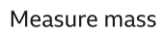  https://vimeo.com/420580932 | .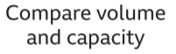  https://vimeo.com/420580980 |  | https://vimeo.com/420581017  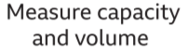 | https://vimeo.com/420581067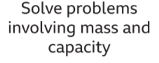 |  | . 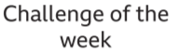  https://vimeo.com/420581067
Foundation Subject |  |  |  |  |  | 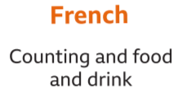

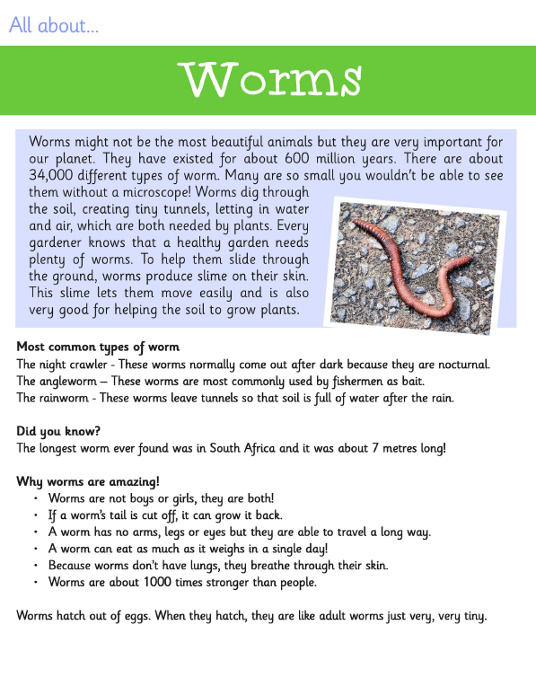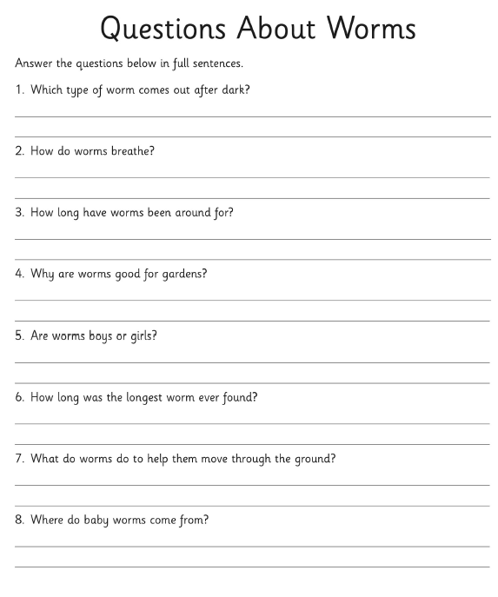

Free Write

Write about what you can see in the picture and maybe answer the some of the following questions:
Why do the trees have bare branches?
What do you think is happening with the boots?
How did the boots get there in the first place?
What will happen next, now that the boots have started moving?

