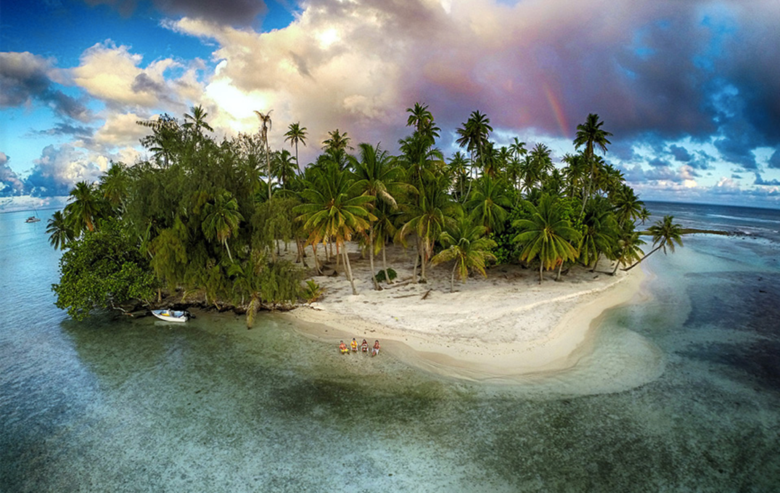
Write about what you can see in the picture and maybe answer some of the following questions:
If you had the chance to go on an island adventure and could only take 3 things, what would you take and why?
Who would you choose to go with you and why?
Where do you think this island might be?

