Suggested Weekly Home Learning Tasks:
Week  13.7. 2020 |  | Monday | Tuesday | Wednesday | Thursday | Friday
Reading |  | To find more books to read you can log onto OxfordOwl. Please open the Oxford Reading tree document on the class page and follow the step by step guide.
 |  | Read to an adult and get them to write in your reading record | Read to an adult and get them to write in your reading record | Choose one of your story books and find your favourite page. Why is it your favourite page? Can you draw it and label it, or write a caption/sentence. | Read to an adult and get them to write in your reading record. | Share a book with an adult. How many of the following tricky words can you find?  So, do, one, out, little  Count them up and make a tally.
Phonics |  | The Department for Education have put together daily phonic lessons, Letters and Sounds for home and school which you can watch on YouTube. Please click on the ‘letter to parents’ and follow guidance. There is a link on the letter that will take you to the YouTube page.  For additional Phonics Practice please use https://www.phonicsplay.co.uk/
 |  | Please use https://www.bbc.co.uk/bitesize/dailylessons for the following week beginning 6th July English and Foundation subject lessons or your red button on your TV
English |  | Action Words | Describing Words | .  Long ladder letters & joining words | Alliteration | Reading Lesson
 |  | Maths is now on White Rose https://whiterosemaths.com/ please use the link with each lesson heading. There are worksheets to accompany the videos.
Maths |  | Find half of objects  https://vimeo.com/434744785 | Find half of amounts  https://vimeo.com/434744955 | Find quarter of objects  https://vimeo.com/434745167 | Find quarter of amounts  https://vimeo.com/434745348 | .  Please refer to BBC Bitesize for today’s work – Challenge of the week
Foundation Subject | Arts Week  Musical Performance |  | Arts Week  Artists and Art | Arts Week  Drama and Theatre | Arts Week  Singing and wellbeing | Arts Week  Ten Pieces Takeover

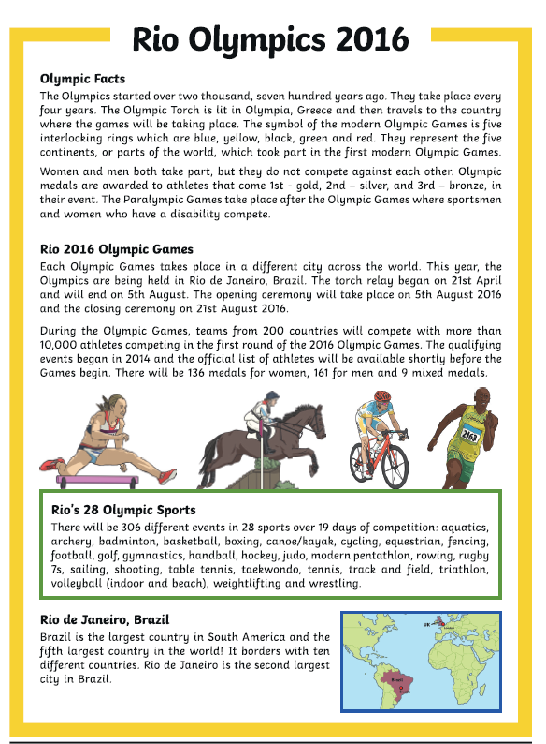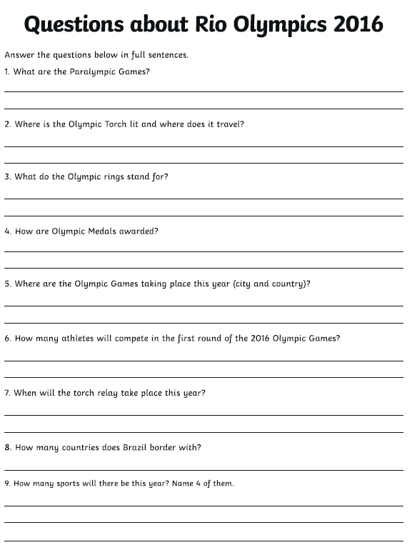
Write about what you can see in the picture and maybe answer the some of the following questions:

If you had the chance to go on an island adventure and could only take 3 things, what would you take and why?
Who would you choose to go with you and why?
Where do you think this island might be?

