Free Write
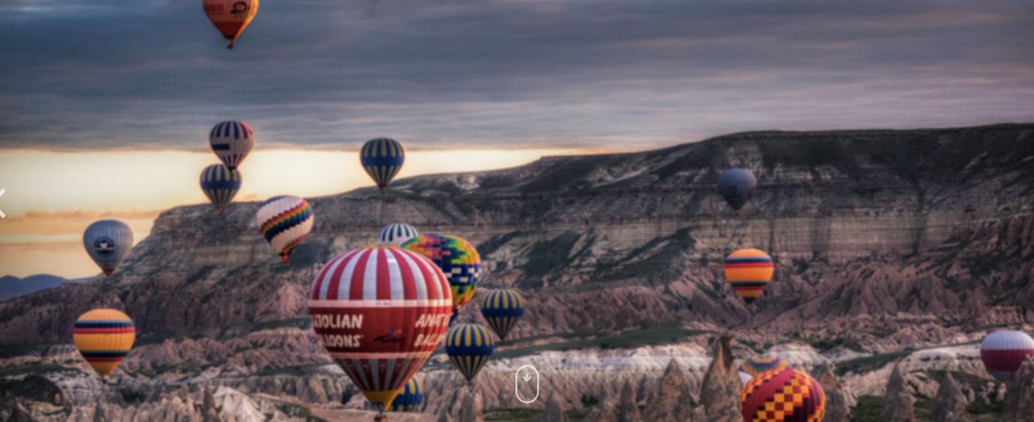

- Where are these people going in hot air balloon?

- What will happen when they get there?

- Who will they see?

- What is it like to be up in the sky?

