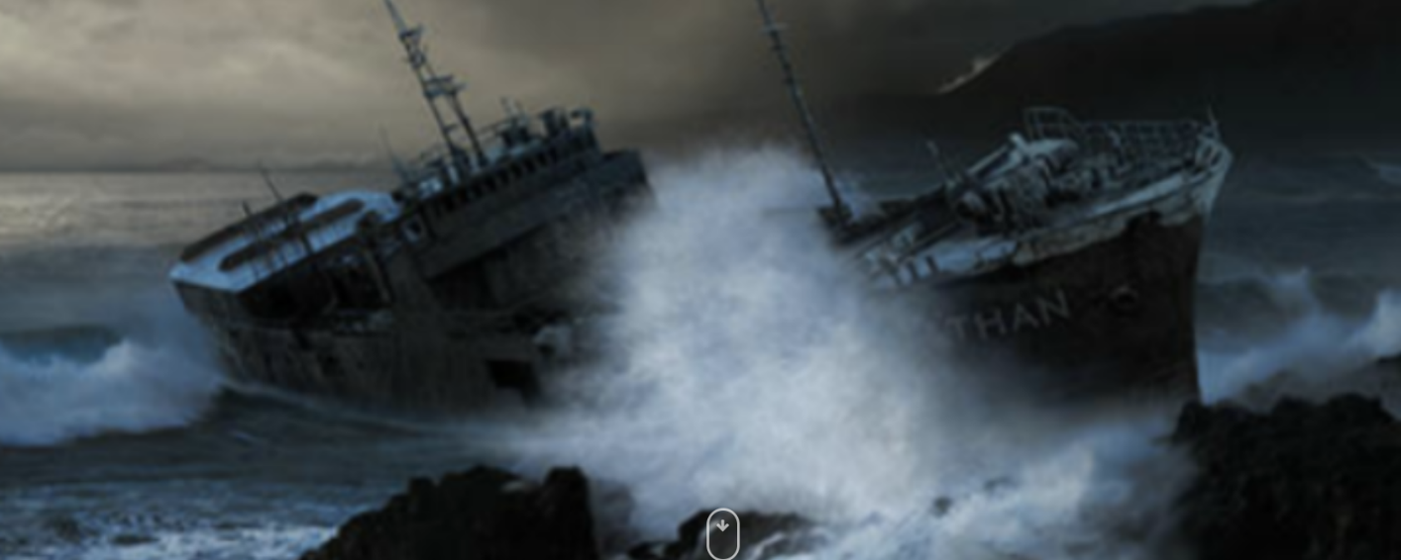
- What is happening here?

- Where was the ship heading?

- How did they crash?

- What happened after the ship crashed?

