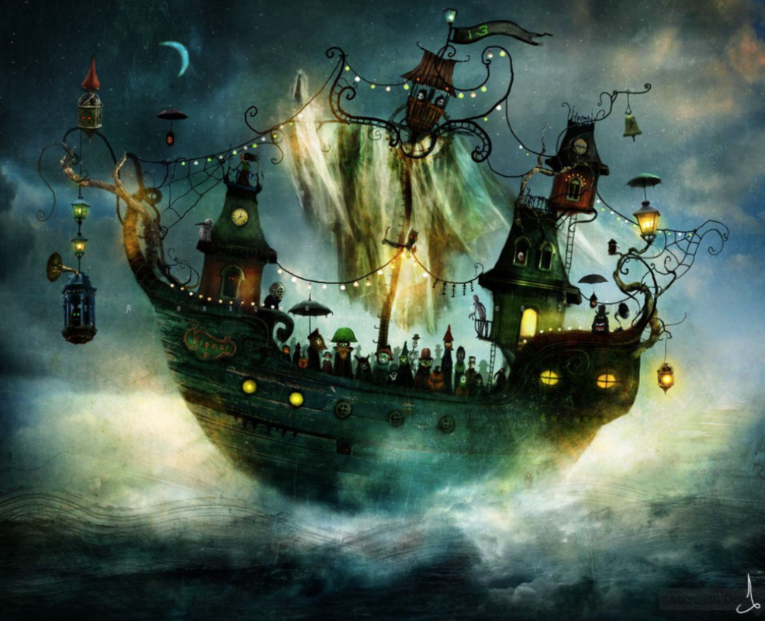
Write about what you can see in the picture and maybe answer some of the following questions:
What is it that is so strange about the ship?
Who do you think the crew are?
How old do you think the ship is?
What do you think the number 13 on the flag means?
What do you think the bell is used for?
Is there anything else strange that you notice about the picture?

