**Books and clips we will study, read and watch together...**

**English**

**Reading**

This half term’s class reader will be The House with Chicken Legs by Sophie Anderson, which we will be reading for pleasure every afternoon. During daily Guided Reading, Year 4 will finish Cloud Busting by Malorie Blackman and then study the Wonder Garden by Jenny Broom. Years 5 and 6 will continue to study Wonder by R. J. Palacio. Over the course of the week, we will all focus on understanding vocabulary, learning how to construct answers to questions, independent comprehension practice, investigating themes in writing (Book Talk) and sharing books for pleasure (Book Chat).

**Writing**

We will continue to focus on using high quality texts and film clips as models for our own writing. This term our stimulus for writing will include: Eye of The Storm by Christopher Alender, So Good To Me by Chris Malinchak and The Last Tree by Ingrid Chabbert. A general focus will be on: accuracy of sentences; paragraphing; writing for audience and purpose; and making effective choices during writing.

**Grammar and Punctuation**

Much of our grammar and punctuation skills will be taught and practiced through our writing in order to contextualise our learning. This term, our learning will include: using colons and semi colons accurately; using a range of sentence types for suspense and emotion, cohesive devices and ensuring the correct tense throughout our writing. We will also be practicing editing whilst we write, making choices about the vocabulary, grammar and punctuation we use.

**Spelling**

This term’s rules include:

Y4: Science vocab, -ssion, -cian, word families, and Y3/4 common spellings

Y5 & 6: Science vocab, homophones, Y5/6 common spellings and individual spelling revision

spelling lists can be found on the class web page along with Common Word lists of year specific spellings.

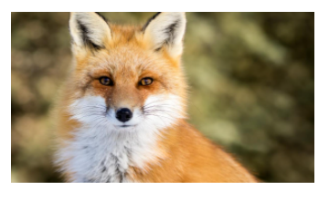

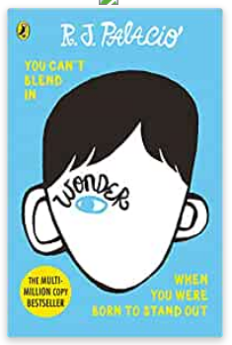

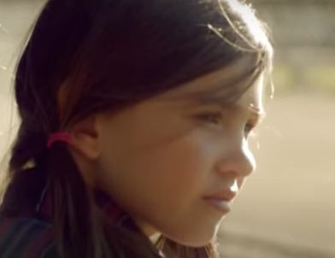

**Other linked books you may like to read….**

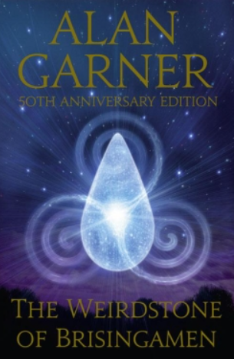

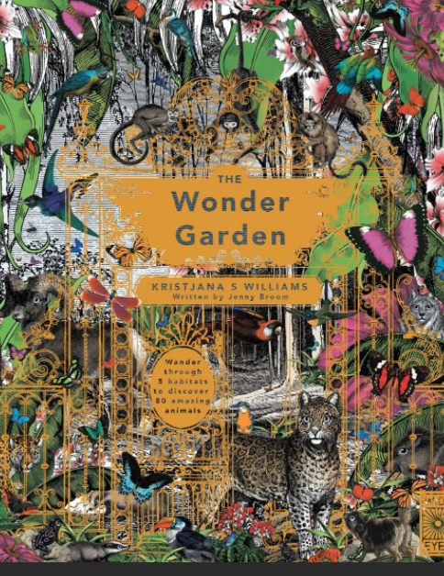

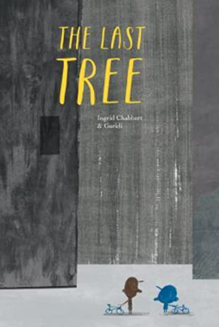

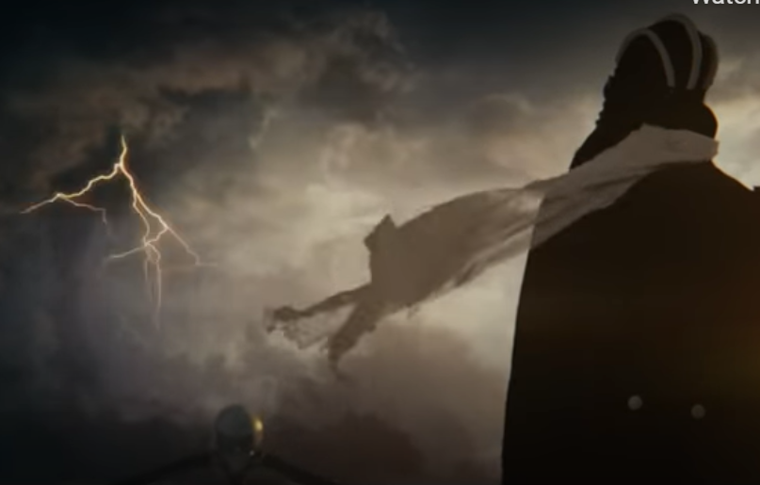

**Maths**

This term’s topics, following the White Rose Scheme, will consolidate and extende areas of mathematical fluency, reasoning and problem solving and include:

**Year 4 topics including** Statistics: interpreting charts; comparison sum and difference; and line graphs. Shape: turn and angles; right angles in shapes; comparing angles; identify angles; comparing and order angles; recognising and describing 2-d shapes; and triangles and quadrilaterals. Position and direction: describing position; drawing on a grid; and moving onjects on a grid.

**Year 5 & 6 topics including** Reflection: reflection; reflection with co-ordinates; translation; and translation with co-ordinates. We will also be revisiting content covered during lock down, as part of a consolidation period at the end of term.

There will be opportunities for additional consolidation of previous learning, in addition to interventions, in order to consolidate and extend knowledge and skills and secure understanding.

All children now have a password and username for Doodle Maths, which is great for further practice of knowledge taught at school. Also try board games, card games and Maths in real life (shopping, telling the time, cooking etc) as great ways to keep Maths fresh in your child’s mind.

**Fox Class**

**Summer, Term 6 2021**

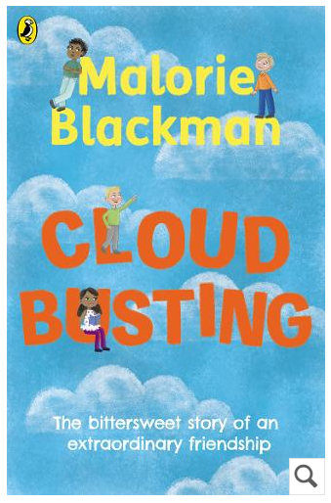

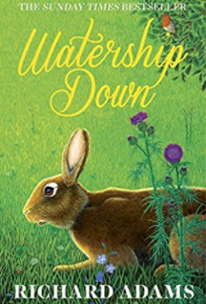

**RE**

This term we will be learning about Special Religious Places. This will include where different religions qorship, what makes them special to their communities and how this compares to our local church, St Giles.

**PE**

This term we will be receiving P.E from one of the Acorn coaches. Remember to come to school wearing the correct PE uniform: house coloured T-shirt; navy leggings or tracksuit bottoms without any logos; navy jumper without a logo or school PE jumper; and trainers.

FOREST SCHOOL FRIDAYS: Remember we have forest school every other Friday. So come well prepared for the weather and with your wellies.

**Music**

This term we will be using music from the Beetles as our basis for learning. We will be learning how to use our voices as instruments, combined with other instruments, during sessions where we will practice, rehearse and perform ‘Blackbird’ by the Beetles.

**PSHE**

In PSHE this term, we will be following the Jigsaw scheme of learning. This will include ‘Changing Me’ for Year 5 & 6 and ‘Relationships’ in Year 4. We will also be having a Health Week, where we will be focusing on how to keep ourselves fit, Healthy and safe.

**Homework**

Every day, children are expected to:

* Read for 10 minutes and get their Reading Record signed by an adult
* Practice their spellings
* Practice their instant recall of times tables and division facts using TT Rockstars. They may also want to have a go on Doodle Maths to support their in-class learning.

**Science**

During this term, we will be studying the topic of ‘Healthy Bodies’. This will include learning about the heart’s role in the circulatory system, what happens when we exercise, what role our lungs play in transporting oxygen, why a healthy balanced diet and exercise are important, the effect of drugs, alcohol and caffeine on our bodies. We will also be working Scientifically by measuring and recording data, and presenting our findings in writing, diagrams and charts.

**Art**

This term, we will be studying some of the works of Leonardo Da Vinci, including The Mona Lisa, Vetruvian Man and The Last Supper. Our skills and outcomes will include focusing on his use of perspective, composition, colour and pencil markings. We will also look at how Da Vinci influenced inventors during, and after, his lifetime.

**Geography**

This term our topic will be on ‘Our World In The Future.’ This will include investigating housing, industry, accessible amenities and local employment that are currently available and how they may change in the future. We will be using some fieldwork skills to collect and record data, as well as using digital software to compare and contrast.