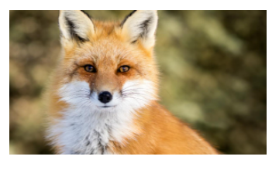

**Fox Class**

**Spring 1 2020**

Books we will use….

**English**

**Reading**

This half term’s class reader will be Journey to the River Sea by Eva Ibbotson, which we will be reading for pleasure every afternoon. During daily Guided Reading, Year 4 will be studying ‘The Firework Maker’s Daughter’ by Phillip Pullman, and Years 5 and 6 The Unforgotten Coat by Frank Cottrell Boyce.

**Writing**

We will continue to focus on using high quality texts as models for our own. This term our stimulus for writing will include: Journey to the River Sea; some extracts from The Hobbit and The Lion The Witch and The Wardrobe; and The Wonder Garden. We will be focusing on linking our writing within and across sentences and between paragraphs.

**Grammar and Punctuation**

Much of our grammar and punctuation skills will be taught and practiced through our writing in order to contextualise our learning. This term, our learning will include: using the perfect form of verbs; using prepositions to express time, adverbials and prepositions to build cohesion; inverted commas and other punctuation for speech, commas to calrify meaning and semi colons to separate independent clauses.

**Spelling**

This term’s rules include:

Y4: in-, il-, im-, ir- prefixes; statutory word list vocab and Geogrpahy linked vocab.

Y5 & 6: -en suffix, dis-, de-, mis prefixes; statutory word list vocab and Geogrpahy linked vocab.

Spelling lists can be found on the class web page along with Common Word lists for additional practice of year specific spellings.

**Maths**

This term’s topics will include learning, consolidating and extending areas of mathematical fluency, reasoning and problem solving.

**Year 4**

**Multiplication and division**: times tables facts including multiplying by 1 and 0; formal written multiplication and division; problem solving

**Measurement:** counting squares to find thearea of rectilinear shapes ; comparing area

**Fractions:** unit and non-unit fractions; common equivalent fractions, fractions greater than 1

**Year 5**

**Statistics:** reading, interpreting and drawing line graphs; reading and interpreting tables; using graphs to solve problems

**Geometry:** perimeter of rectangles and rectilinear shapes; area of rectangles, compound and irregular shapes

**Year 6**

**Number:** ratio and fractions; scale factors and proportion

**Decimals and percentages:** fraction, decimal and percentage conversions; percentages of amounts; adding and subtracting decimals

There will also be opportunities for small group interventions to consolidate areas of maths further.

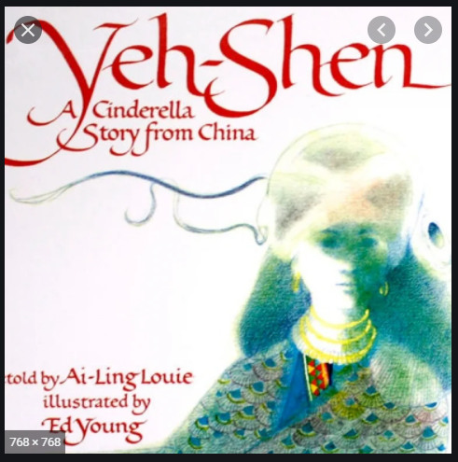

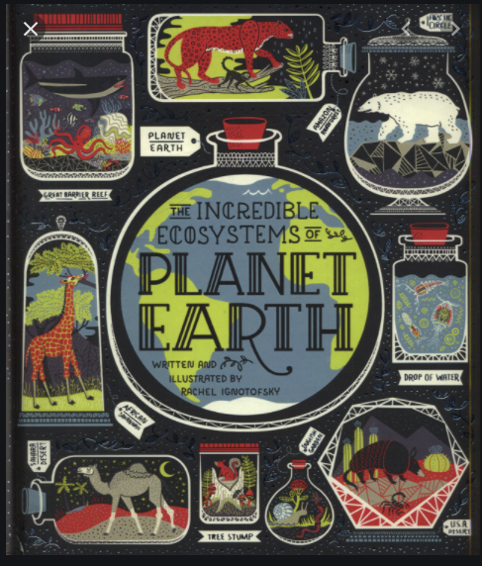

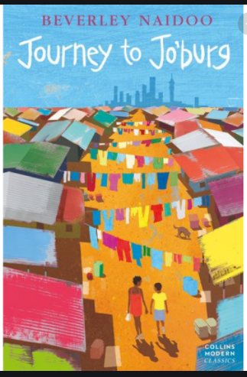

Other books you may like to read….

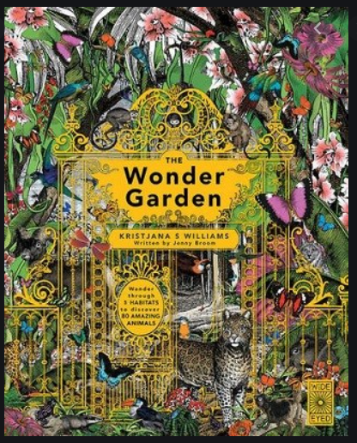

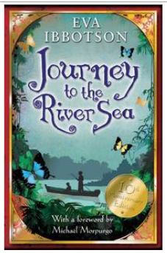

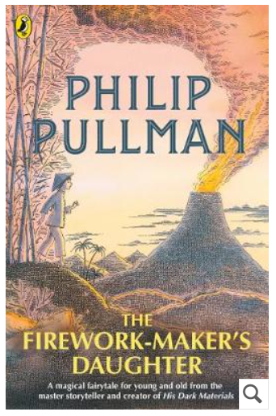

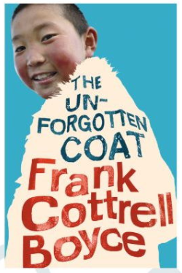

**RE**

This term we will be investigating the question: How important is it for Jewish people to do what God asks them to do?’ We will be learning about Kashrut rules and kosher food; the festival of Passover and how Jews show God they value him.

**Science**

During his term, we will be study the topic ‘Electricity’. This will include: learning electrical sysmbols, explaining why circuits might not work, understanding how to change the brightness of a bulb and how resistors work. We will be working scientifically in areas such as: planning enquiries to answer questions and reporting findings in a variety of ways.

**Art**

This term we will be investigating Chinese art. This will include looking at themes, styles and colours used in traditional Chinese art; how dragons are used; and creating pictures in the style of Chinese art.

**PE**

This term we will be receiving P.E from one of the Acorn coaches. Remember to come to school wearing the correct PE uniform: house coloured top, navy leggings or tracksuit bottoms, navy jumper and trainers.

**Geography**

Our Geography topic this term will be South America: The Amazon. We will be using maps to place The Amazon on a map of South America. We will also be investigating life on The Amazon including comparing climates, researching the city of Manaus and understanding the importance of protecting the Amazon. This will culminate in a non-chronological report about The Amazon, which will be linked to both reading and writing.

**PSHE**

In PSHE this term, we will be following the Jigsaw topic ‘Dreams and Goals’. We will be thinking about: personal learning goals, steps to success, dreams for the world, helping to make a difference and recognising our achievements.

**Homework**

Every week, children are expected to:

* Read for 10 minutes every night and get their Reading Record signed by an adult
* Practice their spellings
* Practice mental maths skills:

- instant recall of times tables and division facts using TT Rockstars

- number knowledge including number bonds, partitioning and place value. <https://www.topmarks.co.uk/maths-games/7-11-years/mental-maths> is a useful game platform to use, but board and card games can work too