Free Write Friday
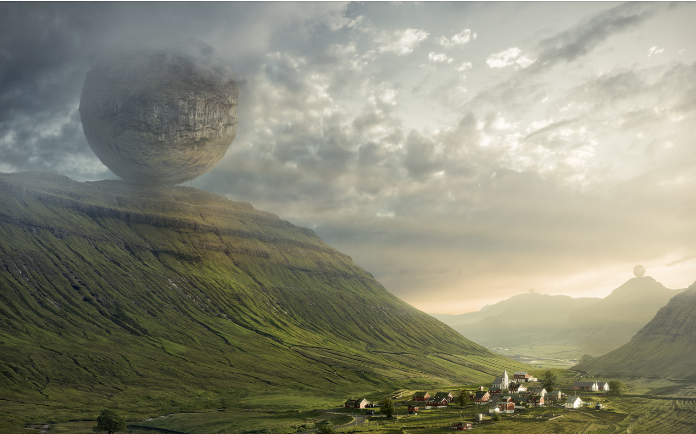
Your task is to write a piece in response to the picture above. It could be a letter from one of the villagers in the town to the owners of the orb, or a story about why there are globes on top of each mountain. You could be a character inside the sphere writing to the people in the village about what might happen if they do not obey your commands! The choice is yours. What you must include, however, are full stops, capital letters, handwriting which is joined and legible and ideas to interest the reader. It would also be great to see where you have tried to use some of the vocabulary, punctuation and grammar you have been taught.
To help you plan, and before you write, think about:
