Suggested Weekly Home Learning Tasks:
Week  29.6. 2020 |  | Monday | Tuesday | Wednesday | Thursday | Friday
Reading |  | To find more books to read you can log onto OxfordOwl. Please open the Oxford Reading tree document on the class page and follow the step by step guide.
 |  | Read to an adult and get them to write in your reading record | Read to an adult and get them to write in your reading record | Choose one of your story books and find your favourite page. Why is it your favourite page? Can you draw it and label it, or write a caption/sentence. | Read to an adult and get them to write in your reading record. | Share a book with an adult. How many of the following tricky words can you find?  Come, some, what, when, have  Count them up and make a tally.
Phonics |  | The Department for Education have put together daily phonic lessons, Letters and Sounds for home and school which you can watch on YouTube. Please click on the ‘letter to parents’ and follow guidance. There is a link on the letter that will take you to the YouTube page.  For additional Phonics Practice please use https://www.phonicsplay.co.uk/
 |  | Please use https://www.bbc.co.uk/bitesize/dailylessons for the following week beginning 22th June English and Foundation subject lessons or your red button on your TV
English |  | Prefixes and Suffixes | Comprehension | .  National Writing Day Lesson | Using one armed robot letters in description | Reading Lesson:  Ella Bella Ballerina & A Midsummer Night’s Dream by James Mayhew
 |  | Maths is now on White Rose https://whiterosemaths.com/ please use the link with each lesson heading. There are worksheets to accompany the videos.
Maths |  | Counting to 100  https://vimeo.com/430314213 | Partition tens and ones  https://vimeo.com/430317914 | Comparing objects to 100  https://vimeo.com/430320026 | Comparing Numbers to 100  https://vimeo.com/430313386 | .  Please refer to BBC Bitesize for today’s work – Challenge of the week
Foundation Subject | History  Mary Seacole |  | Geography  Cities, Towns and Villages | Science  What is sound? | Design & Technology  Food and Nutrition | French  Food, drink, stories and song

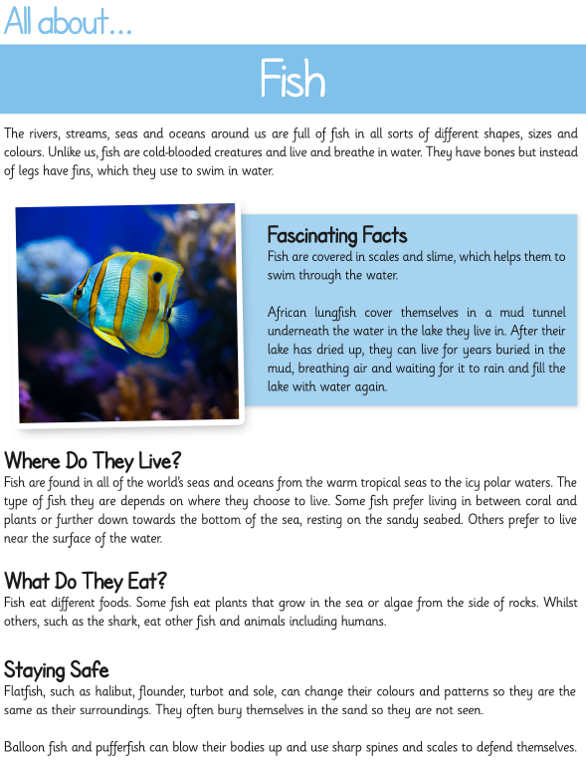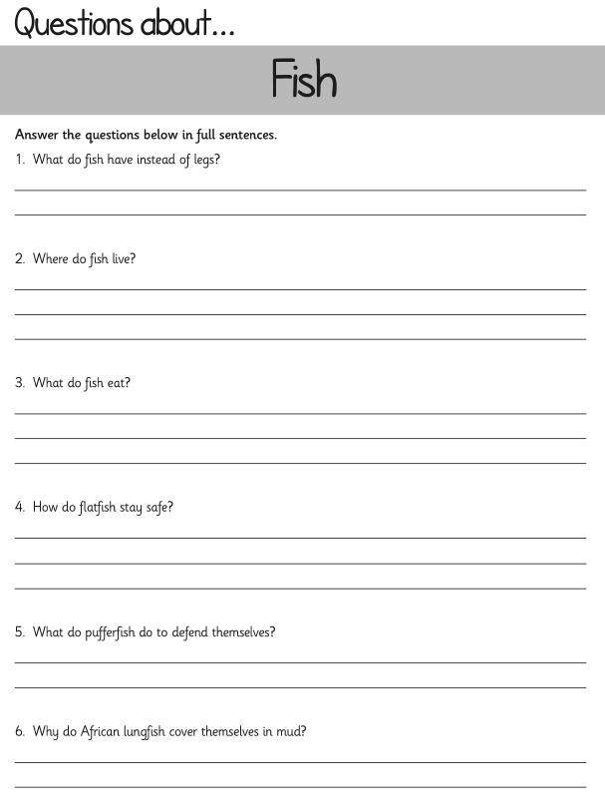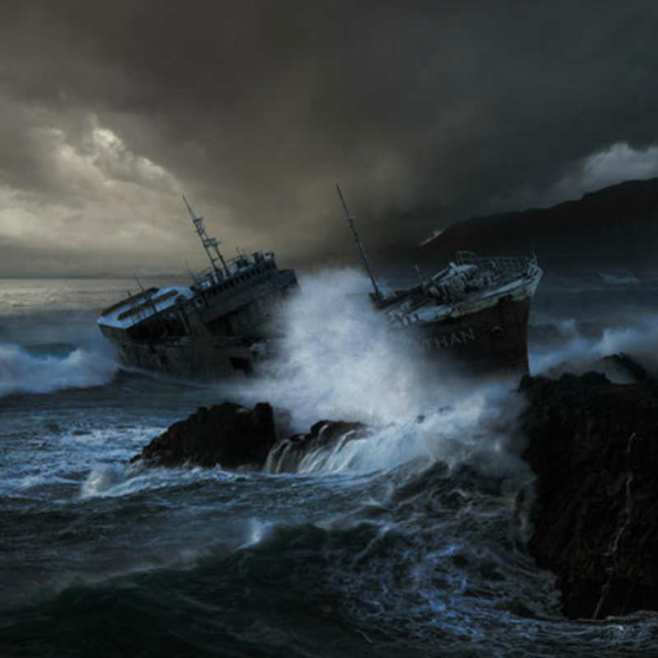
Write about what you can see in the picture and maybe answer the some of the following questions:
What do you think the ship’s name is?
Why are storms so dangerous for ships and their crews?
How many crew do you think are on the ship?
Why does a ship need a crew?
How have ships changed over the course of history?

