**Books we will read together and study….**

**English**

**Reading**

This half term’s class reader will be Journey to the River Sea by Eva Ibbotson, which we will be reading for pleasure every afternoon. During daily Guided Reading, Year 4 will study Cloud Busting by Malorie Blackman, and Years 5 and 6 Wonder by R. J. Palacio.

**Writing**

We will continue to focus on using high quality texts as models for our own. This term our stimulus for writing will include: The Hobbit by JRR Tolkien, The Hobbit Graphic novel by David Wenzel and The Day the Crayons Quit by Oliver Jeffers. A general focus will be on increasing our writing stamina, legibility and accuracy.

**Grammar and Punctuation**

Much of our grammar and punctuation skills will be taught and practiced through our writing in order to contextualise our learning. This term, our learning will include: extending our range of sentence types using conjunctions; organizing paragraphs around a theme; using conjunctions, adverbs and prepositions to express time; and consolidating our knowledge of speech punctuation. We will also be practicing proof reading for spelling and punctuation errors as well as proposing changes to grammar, vocabulary and punctuation to enhance effects.

**Spelling**

This term’s rules include:

Y4:-ious, -eous, -tion, statutory word list.

Y5 & 6: silent p & i, silent s & t, adverbs of possibility, synonyms and antonyms, statutory word list.

Spelling lists can be found on the class web page along with Common Word lists of year specific spellings.

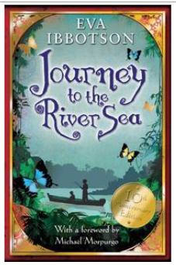

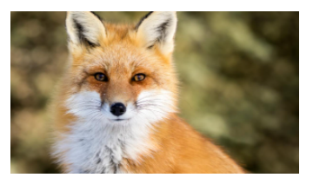

**Fox Class**

**Summer Term 5 2020**

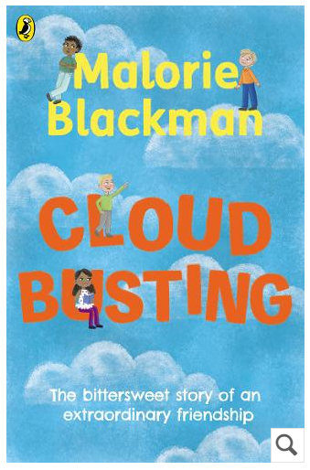

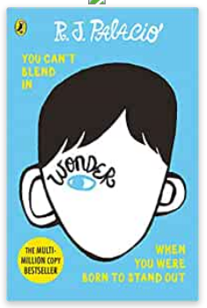

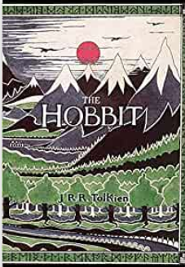

**Maths**

This term’s topics will consolidate and extending areas of mathematical fluency, reasoning and problem solving and include:

**Year 4**

Ordering, writing and comparing decimals; recognizing and calculating with pounds and pence; converting money; telling the time on digital and analogue clocks; 12 and 24 hour clocks; hours, minutes and seconds; years, months, weeks and days.

**Year 5 & 6**

Measuring angles with a protractor, on a straight line and calculating angles; angles in triangles and quadrilaterals; regular and irregular polygons and angles in polygons.

There will also be opportunities for additional teaching of groups, in addition to interventions, to consolidate and extend knowledge and skills in order to secure children’s understanding. .

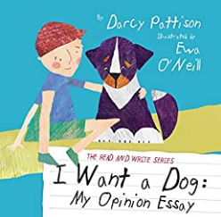

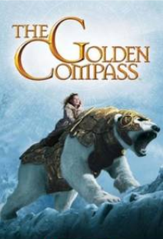

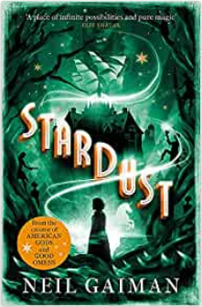

**Other linked books you may like to read….**

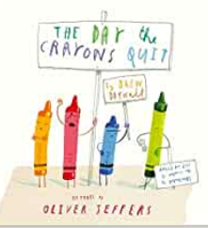

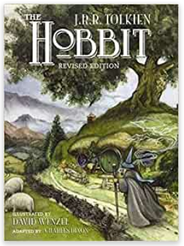

**Music**

This term we will be following the Charanga scheme for music basing our studies around the song ‘Dancing in the Street’ by Martha and the Vandellas.

**RE**

This term we will be learning about the Christian Creation story. We will be talking about the Genesis story and Psalm 8. We will also be comparing and contrasting science and creation.

**Science**

During this term, we will be studying the topic of Human and Animals Over Time. This will include answering the questions: What is the theory of evolution? How do fossils provide evidence for evolution? What are the different animal kingdoms? Which organisms lived during each era of time? What impact have humans had on plants and animals?

**DT**

This term our DT topic will focus on product development. We will be evaluating, making and developing packaging for our own food product, focusing on designing, making and evaluating. This will also include elements of the cooking and nutrition aspects of DT.

**Homework**

Every day, children are expected to:

* Read for 10 minutes and get their Reading Record signed by an adult
* Practice their spellings
* Practice mental maths skills:

- instant recall of times tables and division facts using TT Rockstars

- number knowledge including number bonds, partitioning and place value. <https://www.topmarks.co.uk/maths-games/7-11-years/mental-maths> is a useful game platform to use, but board and card games can work too

**PE**

This term we will be receiving P.E from one of the Acorn coaches. Remember to come to school wearing the correct PE uniform: house coloured T-shirt; navy leggings or tracksuit bottoms without any logos; navy jumper without a logo or school PE jumper; and trainers.

**PSHE**

In PSHE this term, we will be following the Jigsaw scheme of learning’s topic ‘Relationships’. We will be thinking about: significant people in our lives; how grief can affect us; recognizing when people are trying to control us; and how to stay safe when using technology.

**History**

Our History topic this term will be answering the question: Who were the Maya? We will be comparing and contrasting ancient and modern Maya; researching Mayan cities; investigating religion and learning about society during the Mayan period.